
ONEERP Cloud - Product Functional Document
Module – Sales

TEMPLATE CHANGE CONTROL

Version | Author | Reviewed By | Approved By | Effective Date | Change History
1.0 | Sumanth PM  Mahisha Varshini C | Mohan Narasimhan | Rajesh Kumar T | January 05, 2024 | Initial Issue-Draft
1.1 | Sumanth PM  Mahisha Varshini C | Mohan Narasimhan | Rajesh Kumar T | February 07, 2024 | Company Parameters, System Parameters, All Hyperlinks, Scenarios, Mobility Solutions, Role boards items
1.2 | Saikiran Malleli  Mahisha Varshini | Mohan Narasimhan | Rajesh Kumar T | November 22, 2024 | New Feature Updates

DOCUMENT DETAILS

Document Name | Document Type | Practice Area/Business Unit | Confidentiality | Distributed To
Cloud PFD - Sales Module | Product Functional Document | ERP BU | Public-Restricted | ERP Team & Clients

Table of Contents
Module Overview 3
Process pack 4
Masters 6
Setup 13
Transactions 15
Specific Features 94
Processing 140
Queries 141
Reports 143
Document Prints 148
Role Board 153
About Azentio Software 155

Sales Module Overview


- Sales is an activity that involves selling goods and services for running its business.
- The Sales module consists of a series of transactions that collectively represent the entire process of sales in any organization.
- The Sales cycle begins with a prospective of customer enquiring about a product or service and moves on in various stages until the sale is made.

Sales Module functionality is detailed below in the following sequence.
- Prerequisites and Sales Masters
- Setup
- Process pack and Transactions
- Specific Features
- Processing
- Queries
- Reports
- Document Prints
- Role Boards

Sales Process pack

Local Sales
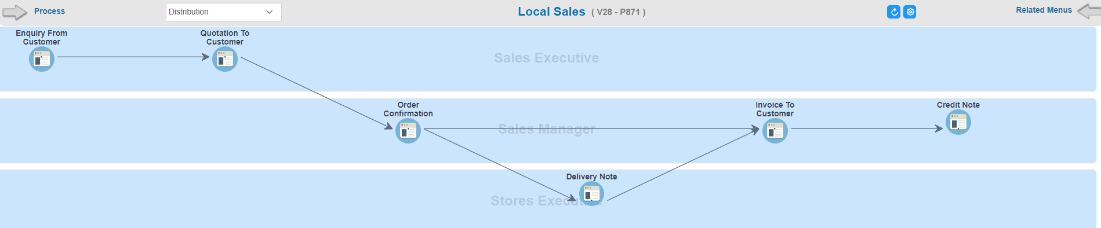

Scenarios
- Enquiry From Customer-Quotation to Customer-Order Confirmation-Delivery Note-Invoice to Customer-Credit Note
- Quotation To Customer-Order Confirmation-Delivery Note-Invoice to Customer-Credit Note
- Order Confirmation-Delivery Note-Invoice to Customer-Credit Note
- Order Confirmation-Invoice to Customer
- Invoice to Customer-Credit Note
- Credit Note
- Purchase Quotation-Sales Quotation

Export Sales
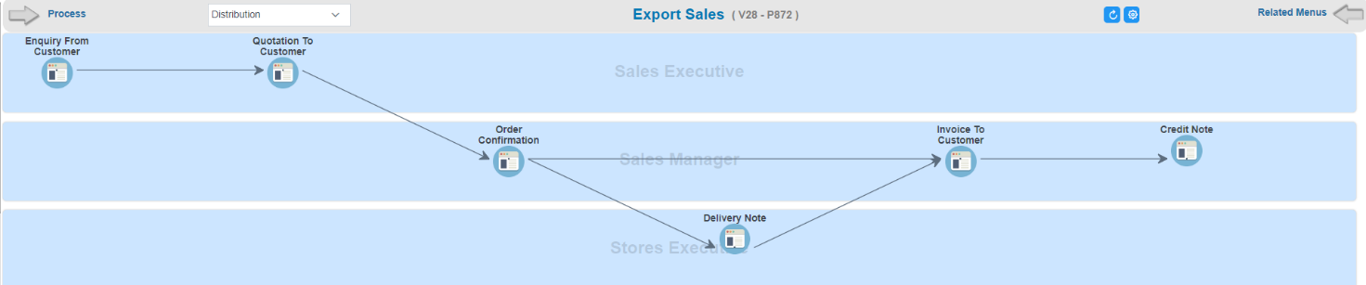

Scenarios
- Enquiry From Customer-Quotation to Customer-Order Confirmation-Delivery Note-Invoice to Customer-Credit Note
- Quotation To Customer-Order Confirmation-Delivery Note-Invoice to Customer-Credit Note
- Order Confirmation-Delivery Note-Invoice to Customer-Credit Note
- Order Confirmation-Invoice to Customer
- Invoice to Customer-Credit Note
- Credit Note
- Purchase Quotation-Sales Quotation

Leads & Opportunities Management
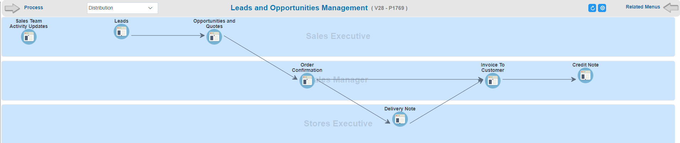

Scenarios
- Leads-Opportunities & quotes-Order Confirmation-Delivery Note-Invoice to Customer-Credit Note
- Opportunities & quotes-Order Confirmation-Delivery Note-Invoice to Customer-Credit Note
- Order Confirmation-Delivery Note-Invoice to Customer-Credit Note
- Order Confirmation-Invoice to Customer
- Invoice to Customer-Credit Note
- Credit Note

Product Lifecycle Management (PLM) Process Pack
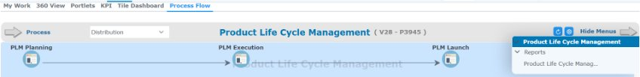

Scenarios
- PLM Planning - PLM Execution - PLM Launch

Sales Masters
These are the prerequisite masters from other modules that need to be configured or setup before proceeding with Sales module.
Procurement (Payment terms)
Inventory (Location Group, Location, UOM, Grades, Item)
Now let us start with the Sales masters that are detailed below.

Address Template
The Objective of this screen is to create template for each address that can be attached to Address Definition.

Address Definition
The Address Definition is used to record the addresses of all the business entities associated with an organization.
Hyperlink | Description
Custom Fields | Custom field refers to a user-defined field that can be added to capture specific data that might not be accommodated by default fields.
Analysis | Captures the analysis data

City
City Master is used to define the cities which user want to create

Country
Country Master is used to define the countries which user want to create

County
County Master is used to define the County which user want to create

Salesman
This master allows the user to create codes to identify the salesman, define percentage of minimum markup and maximum variance. The minimum markup percentage denotes the minimum percentage of profit that the salesman needs to mark per sale. The maximum variance percentage implies the maximum sale price.
Hyperlink | Description
Custom Fields | Custom field refers to a user-defined field that can be added to capture specific data that might not be accommodated by default fields.
Company | Allows the user to enter company codes as defined in the Company master. Each salesman is attached to one or more such companies
Commission | Facilitates to add Commission details

Customer
The Objective of this master is to capture Customer details that will be used in sales related transactions, The details also include accounts receivables defined in the financial Chart of Accounts under which all the financial transactions for the customer are recorded.
Hyperlink | Description
Custom Fields | Custom field refers to a user-defined field that can be added to capture specific data that might not be accommodated by default fields.
Analysis | Captures the analysis data
Contact | Captures the contact details
Attachments | To attach documents that is related to the transaction.
Address | Captures the address information of the Customer
Currency | Currencies in which the Customer is allowed to transact with the company
Company | Captures list of companies to which the Customer can transact in the system
Shipment Mode | Captures shipment mode for goods delivery
Payment Term | Payment terms for all the Transactions
Bank Details | Captures the Customer’s default bank address details
Preferred Item | Captures the default products ordered by the Customer
Close To Expiry Days | Captures details of expiry days before and after which items can be issued to the customer
Notes | Notes feature allows users to add personalized comments, including their automatically retrieved username. These comments can then be printed directly onto the document.
Inco terms | The Incoterms or International Commercial Terms are a series of pre-defined commercial terms published by the International Chamber of Commerce relating to international commercial law. Incoterms master helps to add Incoterm Description with code
More | View the additional header level details for a transaction.

Mode of shipment
Mode of shipment master allows businesses to manage and control various modes of transporting goods or products. It serves as a centralized database or repository within the ERP system where information is related to different shipping methods. Example:(Road, air freight, sea freight, rail, etc.)

TED Type
TED used to define the various types of taxes, expenses and discounts that the company expects to encounter in the course of its business. The method of calculating the TED is also defined. The application supports the use of a PLSQL statement to calculate the TED. It is also possible to specify whether a particular TED type record is required to be available in the TDS (Tax Deducted at Source) module.
Hyperlink | Description
Add TED | Define the various taxes, expenses and discounts that need to be added to arrive at the basis amount on which tax/expense/discount is calculated
Reduce TED | Define the various taxes, expenses and discounts that need to be reduced to arrive at the basis amount on which tax/expense/discount is calculated
PLSQL | Various parameters used in the PLSQL statement are listed in this tab

Tax code
The Tax Code master is used to define the various types of taxation applicable to the business. The screen captures information on the type, basis and level of taxation. It also specifies whom the tax is payable to or collectible from. The validity period of the taxation is also defined here.
Hyperlink | Description
Custom Fields | Custom field refers to a user-defined field that can be added to capture specific data that might not be accommodated by default fields.
Tax Rate | Facilitates to add Tax rate details
Threshold | Capture details regarding the discounts applicable for various value ranges and their validity periods
UOM Details | Facilitates to add UOM details
Transaction Validity | Specify the Transactions for which it is applicable

Tax parameter
Tax parameter defines the type of tax applicable for a company. Before defining the masters, the user must define the Tax parameters applicable for the company.

Expense
The Expense master is used to define the various types of expenses that occur in the day-to-day operations of a company and require to be accounted for, especially with respect to calculating the cost of processes and the price of items.
Hyperlink | Description
Custom Fields | Custom field refers to a user-defined field that can be added to capture specific data that might not be accommodated by default fields.
Expense Rate | Facilitates to add Expense details
Threshold | Capture details regarding the discounts applicable for various value ranges and their validity periods
UOM Details | Facilitates to add UOM details
Transaction Validity | Specify the Transactions for which it is applicable

Discount
This master is used to define the various types of discounts that are used in various transactions. It is possible to define the discount on a quantity/rate as well as on a user defined basis. The system also has the facility of creating slabs for discounts. It is also possible to define threshold values for the discount.
Hyperlink | Description
Custom Fields | Custom field refers to a user-defined field that can be added to capture specific data that might not be accommodated by default fields.
Rate | Facilitates to add rate details
Threshold | Capture details regarding the discounts applicable for various value ranges and their validity periods
UOM Details | Facilitates to add UOM details
A/C Details | Define the various taxes, expenses and discounts that need to be added to arrive at the basis amount on which tax/expense/discount is calculated
Transaction Validity | Specify the Transactions for which it is applicable

VAT Environment
VAT environment refers to the taxation framework and regulations related to the buying and selling of goods or services where VAT is applied.
Hyperlink | Description
Custom Fields | Custom field refers to a user-defined field that can be added to capture specific data that might not be accommodated by default fields.
Country | Facilitates to add Country details

Sale type
The price list applicable to a Sale Type–Location Type combination is defined in the Sale Type master. This definition helps the system in sourcing a specific price list when this Sale Type is used in a Sale Order or Invoice transaction from a particular location. Sale Type is mainly applicable either to excisable sales or to export sales carried out on the basis of an advanced license.
Hyperlink | Description
Sales Type Details | Captures the location and price list type details.
Applicable Duty Impact | Captures the applicable duty for the sales type.

Sales bonus
Sales Bonus or Promotion is a marketing technique used by organizations to increase their sales. A sales Bonus is defined to manage the computation of Free of Cost (FOC) items that are given along with a certain quantity of the main item purchased by customers. Sales bonus is defined at different level (For e.g.: Item, Customer etc.) and there is a link with the Function Level Link screen and discount matrix screen to handle this process.
Hyperlink | Description
Quantity Slab | Define the quantity slab of the main item that qualifies for FOC items. FOC item calculation is based on this slab
Value Slab | Similar to Bonus quantity slab – instead of quantity system has to check the value of the transaction based on which FOC is calculated

Virtual Kit
Virtual Kit master allows the user to create Virtual kit and bundle the component manually and define the price while performing the transactions. This Kit can be used at Sale Order or Invoice level screen and discount matrix screen to handle this process.
Hyperlink | Description
Product Details | Facilitates to add Item details
Applicable Location | Facilitates to add Applicable location details

Customer groups
Customer groups master screen helps to define and add GL group code

Incoterms
The Incoterms or International Commercial Terms are a series of pre-defined commercial terms published by the International Chamber of Commerce relating to international commercial law. Incoterms master helps to add Incoterm Description with code

Form code
Form code can be created in this screen with code and description and can be used in transaction screen. Example: LSSO, LSIN

Item Analysis
Item analysis master helps to add required analysis field for item. which will be reflected in the item master screen.

Supplier Analysis
Supplier Analysis Master allows users to add the necessary analysis fields for suppliers, which will then be reflected on the supplier master screen.

Customer Analysis
Customer Analysis Master enables users to add the required analysis fields for customers, and these additions will be reflected on the customer master screen.

Sales Setup

Sales account
The Sales Account is instrumental in financial reporting, providing a summary of revenue over a specific period. It may be further categorized into sub-accounts, such as product lines or service types, to facilitate more detailed analysis of sales performance. Financial setup for the Sales account has to be done on this screen by entering required details with its main account code.

Customer account
This account serves as a ledger or statement that summarizes the financial dealings with that specific customer. Financial setup for Customer account has to be done in this screen by entering required details with its main account code.

Cash discount account
The Cash Discount Account reflects the financial impact of these discounts on the company's revenue and helps maintain accurate accounting records. Financial setup for a cash discount account has to be done in this screen by entering the required details with its main account code.

Discount account
The Discount Account helps in accounting for the impact of discounts on the overall revenue and reflects the financial adjustments made to accommodate these reductions in the sale amount. The financial setup for discount accounts has to be done in this screen by entering the required details with its main account code.

Cost of sales account
The purpose of this account is to accurately reflect the expenses directly tied to the production or acquisition of goods and to calculate the gross profit of the business. Financial setup for cost of sales account has to be done in this screen by entering required details with its main account code.

Company parameter

Module | Sub-Module | Menu Name | Type | Description
SCM-Operations | SCM- Operation: Bill of Entry | BOE_LOCN | LOCN | BOE LOCATION
SCM-Operations | SCM- Operation: Sales | ADVLICYN | ADVLICYN | Advance License Required Yes
SCM-Operations | SCM- Operation: Sales | COSTSALE | COSTSALE | Margin % as per C-Cost
SCM-Operations | SCM- Operation: Sales | FOCCOSPOST | FOCCOSPOST | Cost of Sales Posting of FOC Item to be done to Free of Cost Item
SCM-Operations | SCM- Operation: Sales | HEADDISCYN | HEADDISCYN | Header Discount on Net Value Y/N
SCM-Operations | SCM- Operation: Sales | IMPEXPCODE | IMPEXPCODE | Importer Exporter Code
SCM-Operations | SCM- Operation: Sales | PANNUMBER | PANNUMBER | PAN NUMBER
SCM-Operations | SCM- Operation: Sales | PENDPOYN | PENDPOYN | Include Pending PO In SO
SCM-Operations | SCM- Operation: Sales | PLIDENTIFY | PLIDENTIFY | Price List Identifier
SCM-Operations | SCM- Operation: Sales | PROF_ORDER | PP_AFT_INV | No
SCM-Operations | SCM- Operation: Sales | SALEPOST | SALEPOST_CUR | Sale Posting in Transaction Currency
SCM-Operations | SCM- Operation: Sales | SALESPL | PLGENTYPE | Normal
SCM-Operations | SCM- Operation: Sales | VALIDTERM | VALIDTERM | Validate Payment Term Y/N

Sales Transaction

Enquiry From Customer
The Sales Enquiry transaction enables you to record the Sales Enquiries received from the Customers. Sales Enquiry does not have an impact on Stock. Financial posting does not apply to this transaction. The following screen displays the Sales Enquiry transaction:

Functional Features
Note: Along with the common operations features the following features are applicable for Enquiry from Customer.
- Item price can be fetched from LOV or manual entry also applicable
- Facility to enable exchange rate (Buying/Selling)
- Price is entered manually Manual Price List entry is allowed
- Facility to include Expense amount

Hyperlink | Description
Custom Fields | Custom field refers to a user-defined field that can be added to capture specific data that might not be accommodated by default fields.
More | Captures the optional information for header details
Terms | Terms is a feature where specific details or exceptions relevant to this record, ensuring both parties are on the same page
Attachments | To attach documents that are related to the transaction.
Authorization | View the details of the approvers for the transaction
Notes | Notes feature allows users to add personalized comments, including their automatically retrieved username. These comments can then be printed directly onto the document.
Amendment History | view transaction amendment history details if any
Sticky Notes | Sticky notes is a feature where comments/remarks can be added & assigned to users to take necessary actions on the same
Workflow | Displays the Current Workflow status as Pending, Current, Completed.
Custom Fields (Item details) | Custom field refers to a user-defined field that can be added to capture specific data that might not be accommodated by default fields.
Delivery Schedule (Item details) | Captures Delivery Schedule of order. This is required in case the System generated Delivery schedule needs to be broken into multiple levels
Alternate Item (Item details) | Facility to record items that alternate with/replace the item code entered during transactions.
Short Close (Item details) | When an item runs out of stock

Transaction Parameter: Enquiry from customer
Transaction parameter Type | Parameter | Value | Description
Auto | Default Vehicle Price List | Default Vehicle Price List | This parameter allows to set default vehicle price list
Auto | Search Vehicle price list level | 1 Search Vehicle Price in Trans Currency, 2 Search Vehicle Price in Base Currency | Search Vehicle price list level is based on the following parameters-1 Search Vehicle Price in Trans Currency, 2 Search Vehicle Price in Base Currency
Documentflow | Amendment after approval | Yes/No | If Amendment option is required after approval, then the parameter can be set as 'Yes', if Amendment after approval is not needed set as 'No'
Documentflow | Authorization Reqd. | Yes/No | If Authorization is required then it can be set as Yes, If the Authorization is not required then it can be changed as No
Documentflow | Horizontal All Authorization Type | 1 Horizontal Any, 2 Horizontal All,3 Vertical All,4 Vertical Bypass, 5 Value Based | Authorization Type can be set from the following 5 options based on user preference. 1 Horizontal Any,2 Horizontal All,3 Vertical All,4 Vertical Bypass,5 Value Based
Documentflow | Authorization Type | 1 Horizontal Any, 2 Horizontal All,3 Vertical All,4 Vertical Bypass, 5 Value Based | Authorization Type can be set from the following 5 options based on user preference. 1 Horizontal Any,2 Horizontal All,3 Vertical All,4 Vertical Bypass,5 Value Based
Documentflow | Vertical All Authorization Type | 1 Horizontal Any, 2 Horizontal All,3 Vertical All,4 Vertical Bypass, 5 Value Based | Authorization Type can be set from the following 5 options based on user preference. 1 Horizontal Any,2 Horizontal All,3 Vertical All,4 Vertical Bypass,5 Value Based
Documentflow | Vertical Bypass Authorization Type | 1 Horizontal Any, 2 Horizontal All,3 Vertical All,4 Vertical Bypass, 5 Value Based | Authorization Type can be set from the following 5 options based on user preference. 1 Horizontal Any,2 Horizontal All,3 Vertical All,4 Vertical Bypass,5 Value Based
Documentflow | Exception Based Approval Yes / No | Yes/No | If Exception Based on Approval is required then Yes parameter can be selected, like wise If Exception Based on Approval is not required select No
Documentflow | Reject to the Previous Level | Previous Level | Rejection level can be selected as Beginning level or Previous level
Documentflow | Reject to the Beginning | Beginning Level | Rejection level can be selected as Beginning level or Previous level
Documentflow | Send Mail for Approval on Submit | Yes/No | If mail has to be sent for approval after submission, then the parameter can be set as Yes, if not required it can be No
Documentflow | Modification required after Submission Yes/ No | Yes/No | If modification required after Submission, then the parameter can be set as Yes, if not required it can be No
Documentflow | Submit for Approval Required Yes / No. | Yes/No | If submit for approval is required then the parameter can be set as Yes, if not it can be No.
Finance | Buying/Selling Rate | Buying, Selling Rate | Select the rate type required from the following 1 Buying, 2 Selling
Finance | Default Price List | Yes/No | This parameter enables to set default price list
Finance | Expense Not Required | Yes/No | If expense is not required then the parameter as to be selected as Yes, if not required No
Finance | Expense Required | Yes/No | If expense is required then the parameter as to be selected as Yes, if not required No
Finance | Search Price List | Yes/No | If search price list option is required then the parameter as to be selected as Yes, if not required No
Finance | Do Not Search Price List | Yes/No | If do not search price list option is required then the parameter as to be selected as Yes, if not required No
Generic | Workflow based on Mapping (Manual) or Criteria (Automatic) | 1 Manual Workflow, 2 Automatic Workflow | Workflow mapping can be selected based on Manual or Automatic
Generic | Attach DMS documents in Workflow mail alert | Yes/No | Attach DMS documents in Workflow mail alert option is required then the parameter can be Yes, if not required it can be No
Generic | Validate documents uploaded in DMS or not during Workflow submit | Yes/No | Validate documents uploaded in DMS or not during Workflow submit, to enable this option the parameter has to be set as Yes. If not needed it can be no
Generic | Upload default txn document in DMS after final approval | Yes/No | Upload default transaction document in DMS after final approval, to enable this option the parameter has to be set as Yes. If not needed it can be no
Generic | Document No Gen. at | 1 Company, 2 Document Source Location, 3 Manual | Document number generation can be selected from the following (1 Company, 2 Document Source Location, 3 Manual)
Generic | Document No Gen. at | 1 Company, 2 Document Source Location, 3 Manual | Document number generation can be selected from the following (1 Company, 2 Document Source Location, 3 Manual)
Generic | Document Upload After Approval Yes/No | Yes/No | If document upload option is required after approval, then the parameter can be set as Yes, if not required it can be set as No
Generic | Modify Flex After Submit/Approval Yes/No | Yes/No | If modification of Flex fields details after submit/approval is required then the parameter can set as Yes, if not required it can be set as No
Generic | Modify Notes After Approval Yes/No | Yes/No | If modification of Notes after approval is required then the parameter can set as Yes, if not required it can be set as No
Generic | Transaction Class | Normal, Vehicle | Transaction class can be selected from the following two field, Normal / Vehicle
Generic | Workflow Code | Workflow Code (STDWF) | Workflow code needed to be selected as standard workflow
Inventory | Non-Stock Not Required | Yes/No | If non-stock item is required then the parameter can be set as Yes, if not required it can be No
Inventory | Non-Stock Required | Yes/No | If non-stock item is required then the parameter can be set as Yes, if not required it can be No
Inventory | Pull Stock/Nonstock/Both | 1 Pull Only Stock Items, 2 Pull Only Non-Stock Items, 3 Pull Stock and Non-Stock Items | Type of stock to be pulled is based on the selection of the following parameter 1 Pull Only Stock Items, 2 Pull Only Non-Stock Items, 3 Pull Stock and Non-Stock Items
Inventory | Superseded Items | 1 IGNORE, 2 WARNING, 3 STOP | For superseded items error pops, up (1 IGNORE, 2 WARNING, 3 STOP based) on the selection of parameter
Inventory | User wise control required to modify Exchange Rate (Y/N) | Yes/No | If user wise control required to modify Exchange Rate, then the parameter can be set as Yes, if not required it can be No

Quotation To Customer
The Sales Quotation is an important stage that determines if the company wins a Sales Order. The quotation contains details such as the rates applicable to items on an estimate basis, and the terms of payment. The system allows you to create Sales Quotations for both prospective and existing customers. These have a validity period.

Functional Features
Note: Along with the operation common features the following features are applicable for Quotation from Customer.
- Facility to enable the quotation for customer or prospect
- Item price can be fetched from LOV or manual entry also applicable
- Re-display price on Item code change
- Facility to enable exchange rate (Buying/Selling)
- Allows discount for the transaction
- Price for an item can be searched based on the customer or transaction level definition
- Facility to pull exchange rate from reference document

Hyperlink | Description
Custom Fields | Custom field refers to a user-defined field that can be added to capture specific data that might not be accommodated by default fields.
More | Captures the optional information for header details
Terms | Terms is a feature where specific details or exceptions relevant to this record, ensuring both parties are on the same page
Reference | Shows the Reference Document number from where the Purchase Enquiry is created.
Attachments | To attach documents that are related to the transaction.
Tax, Expense, Discount | Specify the Tax, Expense and Discount details as applicable
Authorization | View the details of the approvers for the transaction
Notes | Notes feature allows users to add personalized comments, including their automatically retrieved username. These comments can then be printed directly onto the document.
Amendment History | view transaction amendment history details if any
Total | View document value details based on the defined currency type
Sticky Notes | Sticky notes is a feature where comments/remarks can be added & assigned to users to take necessary actions on the same
Workflow | Displays the Current Workflow status as Pending, Current, Completed.
Amendment | User can Amend the transaction by giving the reason
Custom Fields (Item details) | Custom field refers to a user-defined field that can be added to capture specific data that might not be accommodated by default fields.
Tax, Expense, Discount (Item details) | Specify the Tax, Expense and Discount details as applicable
Delivery Schedule (Item details) | Captures Delivery Schedule of order. This is required in case the System generated Delivery schedule needs to be broken into multiple levels
Alternate Item (Item details) | Facility to record items that alternate with/replace the item code entered during transactions.
Short Close (Item details) | When an item runs out of stock

Transaction Parameter: Quotation to customer
Transaction parameter Type | Parameter | Value | Description
Auto | Default Vehicle Price List | Default Vehicle Price List | This parameter allows to set default vehicle price list
Auto | Search Vehicle price list level | 1 Search Vehicle Price in Trans Currency, 2 Search Vehicle Price in Base Currency | Search Vehicle price list level is based on the following parameters-1 Search Vehicle Price in Trans Currency, 2 Search Vehicle Price in Base Currency
Documentflow | Allow Multiple Document Pulling | Yes/No | Multiple Document Pulling option is needed then parameter can be set as 'Yes', Multiple Document Pulling not required set as 'No'
Documentflow | Amendment after approval | Yes/No | If Amendment option is required after approval, then the parameter can be set as 'Yes', if Amendment after approval is not needed set as 'No'
Documentflow | Authorization Reqd. | Yes/No | If Authorization is required then it can be set as Yes, If the Authorization is not required then it can be changed as No
Documentflow | Authorization Type | 1 Horizontal Any, 2 Horizontal All,3 Vertical All,4 Vertical Bypass, 5 Value Based | Authorization Type can be set from the following 5 options based on user preference. 1 Horizontal Any,2 Horizontal All,3 Vertical All,4 Vertical Bypass,5 Value Based
Documentflow | Exception Based Approval Yes / No | Yes/No | If Exception Based on Approval is required then Yes parameter can be selected, like wise If Exception Based on Approval is not required select No
Documentflow | Reject to the Beginning | Beginning Level | Rejection level can be selected as Beginning level or Previous level
Documentflow | Reject to the Previous Level | Previous Level | Rejection level can be selected as Beginning level or Previous level
Documentflow | Send Mail for Approval on Submit | Yes/No | If mail has to be sent for approval after submission, then the parameter can be set as Yes, if not required it can be No
Documentflow | Modification required after Submission Yes/ No | Yes/No | If modification required after Submission, then the parameter can be set as Yes, if not required it can be No
Documentflow | Submit for Approval Required Yes / No. | Yes/No | If submit for approval is required then the parameter can be set as Yes, if not it can be No.
Excise | Edit Assessable Rate - Yes | Yes/No | If edit assessable rate option is required then the parameter as to be selected as Yes, if not required No
Excise | Edit Assessable Rate - No | Yes/No | If edit assessable rate option is required then the parameter as to be selected as Yes, if not required No
Excise | Excise Required No | Yes/No | If excise required then the parameter as to be selected as Yes, if not required No
Excise | Excise Required Yes | Yes/No | If excise required then the parameter as to be selected as Yes, if not required No
Finance | Buying/Selling Rate | 1 Buying, 2 Selling Rate | Select the rate type required from the following 1 Buying, 2 Selling
Finance | Default Price List | Default Price List | This parameter enables to set default price list
Finance | Discount Required YN | Discount Not Required, Discount Required | If discount required then the parameter as to be selected as discount required, if not required select discount not required
Finance | Price List TED pulling based on Customer master Search level Yes/No | Yes/No | If price list TED pulling based on customer master search level is required then the parameter as to be selected as Yes, if not required No
Finance | Price List TED pulling based on Customer master Search level Yes/No | Yes/No | If price list TED pulling based on customer master search level is required then the parameter as to be selected as Yes, if not required No
Finance | Pull expenses from ref doc. | Yes/No | If pull expenses from reference document is required then the parameter as to be selected as Yes, if not required No
Finance | Redisplay price on Item code change | Yes/No | If redisplay price on Item code change is required then the parameter as to be selected as Yes, if not required No
Finance | Search price list level | 1 Search Price in Trans Currency, 2 Search Price in Base Currency, 3 Search in Trans Then Base Currency | Search price list level is based on the following parameter selection- 1 Search Price in Trans Currency, 2 Search Price in Base Currency, 3 Search in Trans Then Base Currency
Generic | Workflow based on Mapping (Manual) or Criteria (Automatic) | 1 Manual Workflow, 2 Automatic Workflow | Workflow mapping can be selected based on Manual or Automatic
Generic | Default Currency / UOM From | 1 Reference Document, 2 Sales Enquiry | Default Currency / UOM From is based on the selection of the following parameter- 1 Reference Document, 2 Sales Enquiry
Generic | Attach DMS documents in Workflow mail alert | Yes/No | Attach DMS documents in Workflow mail alert option is required then the parameter can be Yes, if not required it can be No
Generic | Validate documents uploaded in DMS or not during Workflow submit | Yes/No | Validate documents uploaded in DMS or not during Workflow submit, to enable this option the parameter has to be set as Yes. If not needed it can be no
Generic | Upload default txn document in DMS after final approval | Yes/No | Upload default transaction document in DMS after final approval, to enable this option the parameter has to be set as Yes. If not needed it can be no
Generic | Document No Gen. at | 1 Company, 2 Document Source Location, 3 Manual | Document number generation can be selected from the following (1 Company, 2 Document Source Location, 3 Manual)
Generic | Document Upload After Approval Yes/No | Yes/No | If document upload option is required after approval, then the parameter can be set as Yes, if not required it can be set as No
Generic | Modify Flex After Submit/Approval Yes/No | Yes/No | If modification of Flex fields details after submit/approval is required then the parameter can set as Yes, if not required it can be set as No
Generic | Modify Notes After Approval Yes/No | Yes/No | If modification of Notes after approval is required then the parameter can set as Yes, if not required it can be set as No
Generic | Prospect Quotation - Yes/No | Yes/No | If prospect quotation is required then the parameter can set as Yes, if not required it can be set as No
Generic | Transaction Class | Normal, Vehicle | Transaction class can be selected from the following two field, Normal / Vehicle
Generic | Workflow Code | Workflow Code (STDWF) | Workflow code needed to be selected as standard workflow
Inventory | Non-Stock required | Yes/No | If non-stock item is required then the parameter can be set as Yes, if not required it can be No
Inventory | Pull Stock/Non stock/Both | 1 Pull Only Stock Items, 2 Pull Only Non-Stock Items, 3 Pull Stock and Non-Stock Items | Type of stock to be pulled is based on the selection of the following parameter 1 Pull Only Stock Items, 2 Pull Only Non-Stock Items, 3 Pull Stock and Non-Stock Items
Inventory | Superseded Items | 1 IGNORE, 2 WARNING, 3 STOP | For superseded items error pops, up (1 IGNORE, 2 WARNING, 3 STOP based) on the selection of parameter
Inventory | UOM can be modified | Yes/No | If modification of UOM is required then the parameter can be set as Yes, if not required it can be No
Inventory | User wise control required to modify Exchange Rate (Y/N) | Yes/No | If user wise control required to modify Exchange Rate, then the parameter can be set as Yes, if not required it can be No

Mobility Solution
Sales Quotation -Functional Features
- Sales Quotation can be Created as Direct.
- In Mobility Solution Normal and Serial items are supported.

Sales Order
The customer places the order for the Goods after the approval of the Sales Quotation. The Sales Order Transaction captures details such as the Items that the customer orders, final payment terms, and delivery schedules.

Functional Features
Note: Along with the operation common features the following features are applicable for Sales Order.
- Item price can be fetched from LOV or manual entry also applicable
- Price for an item can be searched based on the customer or transaction level definition
- Re-display price on item code change
- On posting allows expenses apportion at item level
- Financial Transaction Code for Advance Payment
- Enables financial transaction code for PDC
- Allows modification in SO rate even after creating invoice
- Quantity changes in Sales Order should back-update in Sales Quotation
- Holds the transaction if price goes below WAC
- Allows Customer Preferred Item
- Edit Selected Quantity in Batch Picking Screen
- Facility to enable Last purchase order in advance
- Items can be pulled from reference document
- Batch details to be entered manual/based on Item
- Facility to check the Batch Stock
- Options to control the batch close date for the past or future period
- Allows to control near to expire period for batch items
- Allow cross location reservation for single item and Stock Transfer by LTO
- Allows item level delivery location
- Enables financial transaction code for LTO
- Based on this parameter Batch/Serial Number Pick Option
- Allows stock reservation for the transaction
- Enables tolerance level for the SO transaction
- Validate stock availability at the time of transaction creation
- Facility to change reservation validity date
- Delivery Dashboard with Batch and Serial Number
- Tolerance Changes
- Barcode enablement

Hyperlink | Description
Custom Fields | Custom field refers to a user-defined field that can be added to capture specific data that might not be accommodated by default fields.
More | Captures the optional information for header details
Terms | Terms is a feature where specific details or exceptions relevant to this record, ensuring both parties are on the same page
Reference | Shows the Reference Document number from where the Purchase Enquiry is created.
Attachments | To attach documents that is related to the transaction.
Tax, Expense, Discount | Specify the Tax, Expense and Discount details as applicable
Authorization | View the details of the approvers for the transaction
Notes | Notes feature allows users to add personalized comments, including their automatically retrieved username. These comments can then be printed directly onto the document.
Amendment History | view transaction amendment history details if any
Customer Item | Captures the default products ordered by the Customer
Warehouse Details | Captures details, if the Warehouse Management System (WMS) is installed
Advance Payment | Specifies the Bank account details of the supplier for payment processing
Parameter | Specify the Parameter Code, Specification, Measurement Unit
Total | View document value details based on the defined currency type
Sticky Notes | Sticky notes is a feature where comments/remarks can be added & assigned to users to take necessary actions on the same
Workflow | Displays the Current Workflow status as Pending, Current, Completed.
Amendment | User can Amend the transaction by giving the reason
Custom Fields (Item details) | Custom field refers to a user-defined field that can be added to capture specific data that might not be accommodated by default fields.
Virtual Kit (Item details) | Virtual Kit allows the user to create Virtual kit and bundle the component manually and define the price while performing the transactions. This Kit can be used for Sale Order or Invoice level screen and discount matrix screen to handle this process.
Superseded Item (Item details) | Superseded items refer to products or items that have been replaced with newer versions or alternatives before fulfillment, reflecting changes or improvements.
TCS (Item details) | Specify TCS Details
Tax, Expense, Discount (Item details) | Specify the Tax, Expense and Discount details as applicable
Delivery Schedule (Item details) | Captures Delivery Schedule of order. This is required in case the System generated Delivery schedule needs to be broken into multiple levels
Batch (Item details) | Indicate that the selected item is a Batch Item or not. The user is not allowed to modify it. Batch Items are defined in the Item master. The user can specify the batch number the item needs to be transferred.
Serial No (Item details) | Indicate that the selected item has a serial number or not. Serial Item is defined in the Item master. An Item is usually tracked using serial numbers when the unit value of the Item is high. It is possible to specify the serial number to be transferred
Pick Batch (Item details) | Facilitates to pick batch number
Pick Serial (Item details) | Facilitates to pick Serial number
Alternate Item (Item details) | Facility to record items that alternate with/replace the item code entered during transactions.
Short Close (Item details) | When an item runs out of stock
FOC Items (Item details) | Free of cost item can be added
Reservation Location (Item details) | Captures the Reservation location details
Item Select (Item details) | Facilitates to add Item
De-Reserve (Item details) | Facilitates to De-reserve item
Item Status (Item details) | Displays the Item Status for the Item from the new Item Status Dashboard.
Parameter (Item details) | Specify the Parameter Code, Specification, Measurement Unit

Transaction Parameter: Sales order
Transaction parameter Type | Parameter | Value | Description
Auto | Default Vehicle Price List | Default Vehicle Price List | This parameter allows to set default vehicle price list
Auto | PDI Generation allowed Y/N | PDI Generation allowed Y, PDI Generation allowed N | If PDI Generation allowed then the parameter can be set as Yes, if not allowed No
Auto | Search Vehicle price list level | 1 Search Vehicle Price in Trans Currency, 2 Search Vehicle Price in Base Currency | Search Vehicle price list level is based on the following parameters-1 Search Vehicle Price in Trans Currency, 2 Search Vehicle Price in Base Currency
Auto | Trade In Required Yes or No | Yes/No | If trade in required then the parameter can be set as Yes, if not required No
Documentflow | Allocation On Approval | Allocation On Approval - No, Allocation on Approval - Yes | If allocation on approval is required then the parameter can be set as Yes, if not required it can be No
Documentflow | Allow Multiple Document Pulling | Yes/No | Multiple Document Pulling option is needed then parameter can be set as 'Yes', Multiple Document Pulling not required set as 'No'
Documentflow | Amendment after approval | Yes/No | If Amendment option is required after approval, then the parameter can be set as 'Yes', if Amendment after approval is not needed set as 'No'
Documentflow | Authorization Reqd. | Yes/No | If Authorization is required then it can be set as Yes, If the Authorization is not required then it can be changed as No
Documentflow | Authorization Type | 1 Horizontal Any, 2 Horizontal All,3 Vertical All,4 Vertical Bypass, 5 Value Based | Authorization Type can be set from the following 5 options based on user preference. 1 Horizontal Any,2 Horizontal All,3 Vertical All,4 Vertical Bypass,5 Value Based
Documentflow | Blanket SO | Yes/No | If blanket SO is required then the parameter can be set as Yes, if not required it can be No
Documentflow | Exception Based Approval Yes / No | Yes/No | If Exception Based on Approval is required then Yes parameter can be selected, like wise If Exception Based on Approval is not required select No
Documentflow | Post after Approval | Yes/No | If post after approval is required then the parameter can be set as Yes, if not required it can be No
Documentflow | Reject to the Beginning | Beginning Level | Rejection level can be selected as Beginning level or Previous level
Documentflow | Reject to the Previous Level | Previous Level | Rejection level can be selected as Beginning level or Previous level
Documentflow | Send Mail for Approval on Submit | Yes/No | If mail has to be sent for approval after submission, then the parameter can be set as Yes, if not required it can be No
Documentflow | Modification required after Submission Yes/ No | Yes/No | If modification required after Submission, then the parameter can be set as Yes, if not required it can be No
Documentflow | Submit for Approval Required Yes / No. | Yes/No | If submit for approval is required then the parameter can be set as Yes, if not it can be No.
Excise | Edit Assessable Rate - Yes | Yes/No | If edit assessable rate option is required then the parameter as to be selected as Yes, if not required No
Excise | Edit Assessable Rate - No | Yes/No | If edit assessable rate option is required then the parameter as to be selected as Yes, if not required No
Excise | Excise Required Yes | Yes/No | If excise required then the parameter as to be selected as Yes, if not required No
Excise | Excise Required No | Yes/No | If excise required then the parameter as to be selected as Yes, if not required No
Finance | Accounting Entry Value  Check | 1 Individual Entry, 2 Cumulative Entry | Accounting entry value check can be selected based on the following parameter 1 Individual Entry, 2 Cumulative Entry
Finance | Sales - Accounting Entry | 1 Individual, 2 Cumulative | Accounting entry can be selected based on the following parameter 1 Individual Entry, 2 Cumulative Entry
Finance | Expenses apportion to Item | Yes/No | If expenses apportion to item is required then the parameter as to be selected as Yes, if not required No
Finance | Financial Transaction Code for Advance Payment | Advance Fin Txn Code | Financial Transaction Code for Advance Payment can be selected based on this parameter
Finance | Ageing Slot 1 | Ageing Slot 1 | Ageing slot available from slot 1 to 5 can be selected in this parameter
Finance | Ageing Slot 2 | Ageing Slot 2 | Ageing slot available from slot 1 to 5 can be selected in this parameter
Finance | Ageing Slot 3 | Ageing Slot 3 | Ageing slot available from slot 1 to 5 can be selected in this parameter
Finance | Ageing Slot 4 | Ageing Slot 4 | Ageing slot available from slot 1 to 5 can be selected in this parameter
Finance | Ageing Slot 5 | Ageing Slot 5 | Ageing slot available from slot 1 to 5 can be selected in this parameter
Finance | Buying/Selling Rate | 1 Buying, 2 Selling | Select the rate type required from the following 1 Buying, 2 Selling
Finance | Consignment SO | Yes/No | If consignment SO is required then the parameter as to be selected as Yes, if not required No
Finance | Default Price List | Default Price List | This parameter enables to set default price list
Finance | Discount Required YN | 1 Discount Not Required, 2Discount Required | If discount required then the parameter can be set as discount required, if not required select discount not required
Finance | Discount Separate Account Y/N | Yes/No | If discount separate account, then the parameter can be set as Yes, if not required it can be No
Finance | Sales Order Final Posting Y/N | Yes/No | If sales order final posting is required then the parameter can be set as Yes, if not required it can be No
Finance | Financial Transaction Code | Financial Transaction Code | For financial transaction code select the required parameter
Finance | Force party code in posting | Yes/No | If force party code in posting is required then the parameter can be set as Yes, if not required it can be No
Finance | GL Posting required Yes / No | Yes/No | If GL Posting is required then the parameter can be set as Yes, if not required it can be No
Finance | LC Check Required Y/N | Yes/No | If LC check is Required then the parameter can be set as Yes, if not required it can be No
Finance | If Net price goes below WAC | 1 Allow Net Price Below WA, 2 Warn If Net Price Goes Below WAC, 3 Net Price Below WAC Not Allowed | If Net price goes below WAC based on the selection of the following parameter the validation takes place-1 Allow Net Price Below WAC, 2 Warn If Net Price Goes Below WAC, 3 Net Price Below WAC Not Allowed
Finance | PDC Transaction Code | PDC Transaction Code | For PDC transaction code select the required parameter
Finance | Price List TED pulling based on Customer master Search level Yes/N0 | Yes/No | If price list TED pulling based on customer master search level is required then the parameter as to be selected as Yes, if not required No
Finance | Price List TED pulling based on Customer master Search level Yes/No | Yes/No | If price list TED pulling based on customer master search level is required then the parameter as to be selected as Yes, if not required No
Finance | Redisplay price on Item code change | Yes/No | To Redisplay price on Item code change then the parameter can be set as Yes, if not required it can be No
Finance | Financial Transaction Code for Advance Refund | Advance Refund Fin Txn Code | Financial Transaction Code for Advance Refund select the required parameter
Finance | Search price list level | 1 Search Price in Trans Currency, 2 Search Price in Base Currency, 3 Search in Trans Then Base Curr | Search price list level is based on the following parameter selection- 1 Search Price in Trans Currency, 2 Search Price in Base Currency, 3 Search in Trans Then Base Curr
Finance | So, Rate change allowed after invoicing | Yes/No | So, rate change allowed after invoicing if the parameter set as Yes, if not required it can be No
Finance | Sales Order to Back update Sales Quotation required Yes / No | Yes/No | Sales Order to Back update Sales Quotation required then the parameter can be set as Yes, if not required it can be No
Finance | If price goes below WAC | 1 Price Below WAC Not Allowed, 2 Warn If Price Goes Below WAC, 3 Allow Price Below WAC | If price goes below WAC based on the selection of the following parameter the validation takes place - 1 Price Below WAC Not Allowed, 2 Warn If Price Goes Below WAC, 3 Allow Price Below WAC
Generic | Workflow based on Mapping (Manual) or Criteria (Automatic) | 1 Manual Workflow, 2 Automatic Workflow | Workflow mapping can be selected based on Manual or Automatic
Generic | Customer Preferred Item | Yes/No | If customer preferred item is required then the parameter can set as Yes, if not required it can be set as No
Generic | Default Order Type | Default Order Type | Default Order Type can be selected using this parameter
Generic | Attach DMS documents in Workflow mail alert | Yes/No | Attach DMS documents in Workflow mail alert option is required then the parameter can be Yes, if not required it can be No
Generic | Validate documents uploaded in DMS or not during Workflow submit | Yes/No | Validate documents uploaded in DMS or not during Workflow submit, to enable this option the parameter has to be set as Yes. If not needed it can be no
Generic | Upload default txn document in DMS after final approval | Yes/No | Upload default transaction document in DMS after final approval, to enable this option the parameter has to be set as Yes. If not needed it can be no
Generic | Document No Gen. at | 1 Company, 2 Document Source Location, 3 Manual | Document number generation can be selected from the following (1 Company, 2 Document Source Location, 3 Manual)
Generic | Document Upload After Approval Yes/No | Yes/No | If document upload option is required after approval, then the parameter can be set as Yes, if not required it can be set as No
Generic | Edit Selected Quantity in Batch Picking Screen Required Yes/No | Yes/No | To edit selected quantity in batch picking screen then the parameter can be set as Yes, if not required it can be set as No
Generic | Modify Flex After Submit/Approval Yes/No | Yes/No | If modification of Flex fields details after submit/approval is required then the parameter can set as Yes, if not required it can be set as No
Generic | Incoterms Applicable Yes/No | Yes/No | If Inco terms is applicable then the parameter can be set as Yes, if not required it can be set as No
Generic | Invoice Instance | Invoice Instance | Invoice Instance can be selected using this parameter by selecting invoice instance
Generic | Invoice Transaction Code | Invoice Transaction Code | Invoice transaction code can be set using this parameter by selecting invoice transaction code
Generic | Consider locked position for sales order reservation | Yes/No | To consider locked position for sales order reservation then the parameter can be set as Yes, if not required it can be set as No
Generic | LPO in Advance Y/N | Yes/No | If LPO in advance is required then the parameter can be set as Yes, if not required it can be set as No
Generic | Modify Notes After Approval Yes/No | Yes/No | If modification of Notes after approval is required then the parameter can set as Yes, if not required it can be set as No
Generic | Allow to generate PO (Y/N) | Yes/No | To Allow to generate PO is required then the parameter can set as Yes, if not required it can be set as No
Generic | Pull Block Details from ref doc. | Yes/No | To pull block details from reference document then the parameter can be set as Yes, if not required it can be set as No
Generic | Quote from same customer (Y/N) | Yes/No | If Quote from same customer is required then the parameter can be set as Yes, if not required it can be set as No
Generic | RESCHEDULE DELIVERY DATE | Yes/No | If reschedule delivery date is required then the parameter can be set as Yes, if not required it can be set as No
Generic | SO, Amend During Wave Transaction Y/N | Yes/No | If SO, amend during wave transaction is required then the parameter can be set as Yes, if not required it can be set as No
Generic | SO Txn Flow | 1 SO-Wave-DO-Invoice, 2 SO-Invoice-Wave-DO, 3 SO-DO-Invoice, 4 SO-Invoice-DO, 5 SO-Wave -DN- CUM-Invoice, 6 SO-DN- CUM-Invoice | SO, Transaction flow can be selected based on the following parameter-1 SO-Wave-DO-Invoice, 2 SO-Invoice-Wave-DO, 3 SO-DO-Invoice, 4 SO-Invoice-DO, 5 SO- Wave- DN- CUM- Invoice, 6 SO- DN- CUM-Invoice
Generic | Transaction Class | Normal, Vehicle | Transaction class can be selected from the following two field, Normal / Vehicle
Generic | Validate Unique LPO Number | Yes/No | To validate unique LPO number then the parameter can be set as Yes, if not required it can be set as No
Generic | Wave transaction Code | WAVE | Wave transaction Code can be set using this parameter by selecting the wave option.
Generic | Workflow Code | Workflow Code (STDWF) | Workflow code needed to be selected as standard workflow
Inventory | Barcode Scan Required | Yes/No | If Barcode Scan required then the parameter can be set as Yes, if not required it can be No
Inventory | Batch details to be entered manual/based on Item Master | 1 Batch base - Manual, 2 Batch base - Item Master | Batch details can be selected based on the following parameter- manual/based on Item Master
Inventory | Batch Close Days with Sign | Batch Close Days with Sign | Batch close days with sign can be set using this parameter
Inventory | Batch Stock Check Allowed YN | Yes/No | if batch stock check is allowed hen the parameter can be set as Yes, if not required it can be No
Inventory | Search Level for Close Days | 1 Transaction level,2 Customer and Item level,3 Customer Level,4 Item Level | Search Level for Close Days can be set based on the selection of following parameters- 1 Transaction level,2 Customer and Item level,3 Customer Level,4 Item Level
Inventory | Delivery Location at Item Level | Yes/No | If delivery location at item level is required then the parameter can be set as Yes, if not required it can be No
Inventory | Field Focus After Barcode | 1 QUANTITY, 2 UOM | Field focus after barcode can be set based on the following parameter-1 QUANTITY, 2 UOM
Inventory | Allow Cross Location Reservation and Stock Transfer by LTO | Yes/No | To allow cross location reservation and stock Transfer by LTO then the parameter can be set as Yes, if not required it can be No
Inventory | Delivery Location Mandatory Y/N | Yes/No | To set delivery location as mandatory then the parameter can be set as Yes, if not required it can be No
Inventory | LTO Transaction Code | LTO Transaction Code | LTO transaction code can be selected using this parameter
Inventory | Non-Stock required | Yes/No | If non-stock item is required then the parameter can be set as Yes, if not required it can be No
Inventory | Batch/Serial Number Pick Option Required Yes/No | Yes/No | If batch/ serial number pick option is required then the parameter can be set as Yes, if not required it can be No
Inventory | Pull Stock/Non stock/Both | 1 Pull Only Stock Items, 2 Pull Only Non-Stock Items, 3 Pull Stock and Non-Stock Items | Type of stock to be pulled is based on the selection of the following parameter 1 Pull Only Stock Items, 2 Pull Only Non-Stock Items, 3 Pull Stock and Non-Stock Items
Inventory | Repull TED From Environment When Document Details are Changed | 1 Repull TED from Environment - Yes, 2 Repull TED from Environment - No | Repull TED From Environment When Document Details are Changed based on the selection of following parameter- 1 Repull TED from Environment - Yes, 2 Repull TED from Environment - No
Inventory | Stock Reservation allowed | Yes/No | If Stock Reservation is allowed then the parameter can be set as Yes, if not required it can be No
Inventory | Reservation level | Location | Reservation level can be set using this parameter
Inventory | Sales Order Tolerance Required Yes/No | Yes/No | If sales order tolerance is required then the parameter can be set as Yes, if not required it can be No
Inventory | Stock Check Allowed YN | Yes/No | If stock check allowed then the parameter can be set as Yes, if not required it can be No
Inventory | Superseded Items | 1 IGNORE, 2 WARNING, 3 STOP | For superseded items error pops, up (1 IGNORE, 2 WARNING, 3 STOP based) on the selection of parameter
Inventory | UOM can be modified | Modify UOM - Yes, Modify UOM - No | If modification of UOM is required then the parameter can be set as Yes, if not required it can be No
Inventory | User wise control required to modify Exchange Rate (Y/N) | Yes/No | If user wise control required to modify Exchange Rate, then the parameter can be set as Yes, if not required it can be No
Inventory | Reservation Validity date change required Y/N | Yes/No | If reservation validity date change is required then the parameter can be set as Yes, if not required it can be No
Inventory | Reservation Validity date change required Y/N | Yes/No | If reservation validity date change is required then the parameter can be set as Yes, if not required it can be No
Statutory | TCS Applicable - Yes/No | Yes/No | If TCS is required then the parameter can set as Yes, if not required it can be set as No

Mobility Solution
Sales Order - Functional Features:
- Create the Sales Order as Direct and reference pulling from sales quotation also provided.
- In Mobility Solution Normal items is supported

Delivery Note
A delivery note is a document that lists all the goods included in a delivery, and is often referred to as a dispatch note, or goods receipt. The note is included in the shipment and lists the quantity of products included in the delivery.

Hyperlink | Description
Custom Fields | Custom field refers to a user-defined field that can be added to capture specific data that might not be accommodated by default fields.
More | Captures the optional information for header details
Terms | Terms is a feature where specific details or exceptions relevant to this record, ensuring both parties are on the same page
Reference | Shows the Reference Document number from where the Purchase Enquiry is created.
Attachments | To attach documents that are related to the transaction.
Tax, Expense, Discount | Specify the Tax, Expense and Discount details as applicable
Authorization | view transaction amendment history details if any
Notes | Notes feature allows users to add personalized comments, including their automatically retrieved username. These comments can then be printed directly onto the document.
Create GRN | Facilitates to create Inter-company GRN
Due Date | Lists the Due date if available.
Payment | Specify the Payment details
Parameter | Specify the Parameter Code, Specification, Measurement Unit
Total | View document value details based on the defined currency type
Sticky Notes | Sticky notes is a feature where comments/remarks can be added & assigned to users to take necessary actions on the same
Workflow | Displays the Current Workflow status as Pending, Current, Completed.
Custom Fields (Item details) | Custom field refers to a user-defined field that can be added to capture specific data that might not be accommodated by default fields.
More (Item details) | Captures the optional information for header details
Virtual Kit (Item details) | Virtual Kit allows the user to create Virtual kit and bundle the component manually and define the price while performing the transactions. This Kit can be used at Sale Order or Invoice level screen and discount matrix screen to handle this process.
TCS (Item details) | Specify TCS Details
Tax, Expense, Discount (Item details) | Specify the Tax, Expense and Discount details as applicable
Delivery Schedule (Item details) | Captures Delivery Schedule of order. This is required in case the System generated Delivery schedule needs to be broken into multiple levels
Batch (Item details) | Indicate that the selected item is a Batch Item or not. The user is not allowed to modify it. Batch Items are defined in the Item master. The user can specify the batch number the item needs to be transferred.
Serial No (Item details) | Indicate that the selected item has a serial number or not. Serial Item is defined in the Item master. An Item is usually tracked using serial numbers when the unit value of the Item is high. It is possible to specify the serial number to be transferred
Pick Batch (Item details) | Facilitates to pick batch number
Pick Serial (Item details) | Facilitates to pick serial number
Alternate Item (Item details) | Facility to record items that alternate with/replace the item code entered during transactions.
Multiple Delivery (Item details) | Lists the Multiple delivery if available.
Item Status (Item details) | Displays the Item Status for the Item from the new Item Status Dashboard.
Bin (Item details) | Bins are physical containers, like shelves or drawers, designated for specific inventory items. They keep goods organized, accessible, and protected in warehouses and stockrooms.
FOC Items (Item details) | Free of cost item can be added
Parameter (Item details) | Specify the Parameter Code, Specification, Measurement Unit

Transaction Parameter: Delivery Note
Transaction parameter Type | Parameter | Value | Description
Auto | Default Vehicle Price List | Default Vehicle Price List | This parameter allows to set default vehicle price list
Auto | Receipt Transaction Code | Financial Receipt Transaction Code | Receipt transaction code can be set using this parameter
Auto | Financial Trade in Transaction Code | Financial Receipt Transaction Code | Financial trade in transaction code can be set using this parameter
Auto | Multi Receipt Required Yes OR No | Multi Receipt Required Yes OR No | If multi receipt is required then the parameter can be set as Yes, if not required it can be No
Auto | Search Vehicle price list level | 1 Search Vehicle Price in Trans Currency, 2 Search Vehicle Price in Base Currency | Search Vehicle price list level is based on the following parameters-1 Search Vehicle Price in Trans Currency, 2 Search Vehicle Price in Base Currency
Auto | Trade In Required Yes or No | Yes/No | If trade in required then the parameter can be set as Yes, if not required No
Documentflow | Allow Multiple Document Pulling | Yes/No | Multiple Document Pulling option is needed then parameter can be set as 'Yes', Multiple Document Pulling not required set as 'No'
Documentflow | Amendment after approval | Yes/No | If Amendment option is required after approval, then the parameter can be set as 'Yes', if Amendment after approval is not needed set as 'No'
Documentflow | Authorization Reqd. | Yes/No | If Authorization is required then it can be set as Yes, If the Authorization is not required then it can be changed as No
Documentflow | Authorization Type | 1 Horizontal Any, 2 Horizontal All,3 Vertical All,4 Vertical Bypass, 5 Value Based | Authorization Type can be set from the following 5 options based on user preference. 1 Horizontal Any,2 Horizontal All,3 Vertical All,4 Vertical Bypass,5 Value Based
Documentflow | Exception Based Approval Yes / No | Yes/No | If Exception Based on Approval is required then Yes parameter can be selected, like wise If Exception Based on Approval is not required select No
Documentflow | Doc type (DOC/XLS/PDF/HTML/XML) | 1 Doc- Document type for Send Mail on Approval, 2 XLS-Document type for Send Mail on Approval,3 PDF-Document type for Send Mail on Approval,4 HTML- Document type for Send Mail on Approval,5 XML Document type for Send Mail on Approval | Doc type (DOC/XLS/PDF/HTML/XML) can be selected using this parameter
Documentflow | Posting after Confirmation | Yes/No | If posting after confirmation is required then the parameter can be set as Yes, if not it can be No.
Documentflow | Reject to the Previous Level | Previous Level | Rejection level can be selected as Beginning level or Previous level
Documentflow | Reject to the Beginning | Beginning Level | Rejection level can be selected as Beginning level or Previous level
Documentflow | Send Mail for Approval on Submit | Yes/No | If mail has to be sent for approval after submission, then the parameter can be set as Yes, if not required it can be No
Documentflow | Send Mail on Approval Y/N | Yes/No | If Mail has to be set on approval, then the parameter can be set as Yes, if not it can be No.
Documentflow | Modification required after Submission Yes/ No | Yes/No | If modification required after Submission, then the parameter can be set as Yes, if not required it can be No
Documentflow | Submit for Approval Required Yes / No. | Yes/No | If submit for approval is required then the parameter can be set as Yes, if not it can be No.
Excise | Default priority code for Online Utilization | Default Priority Code | If default priority code for online utilization is required then the parameter as to be selected as Yes, if not required No
Excise | Duty Register Selection type -  Automatic PARTIAL | AUTOMATIC-PARTIAL | Duty Register Selection type can be selected based on the selection of the following parameter (Automatic -partial, Automatic- Full, Manual)
Excise | Duty Register Selection type - Automatic FULL | AUTOMATIC-FULL | Duty Register Selection type can be selected based on the selection of the following parameter (Automatic -partial, Automatic- Full, Manual)
Excise | Duty Register Selection type - Manual | MANUAL | Duty Register Selection type can be selected based on the selection of the following parameter (Automatic -partial, Automatic- Full, Manual)
Excise | Duty Register Updation type - Batch | BATCH | Duty Register updation type can be selected based on the selection of the following parameter-Batch, online
Excise | Duty Register Updation type - Online | ONLINE | Duty Register updation type can be selected based on the selection of the following parameter-Batch, online
Excise | Edit Assessable Rate - No | Yes/No | If edit assessable rate option is required then the parameter as to be selected as Yes, if not required No
Excise | Edit Assessable Rate - Yes | Yes/No | If edit assessable rate option is required then the parameter as to be selected as Yes, if not required No
Excise | Excise duty Mandatory - Yes | Yes/No | If excise duty is mandatory then the parameter as to be selected as Yes, if not required No
Excise | Excise duty Mandatory -- No | Yes/No | If excise duty is mandatory then the parameter as to be selected as Yes, if not required No
Excise | Generate Excise Invoice - No | Yes/No | If generate excise invoice is required then the parameter as to be selected as Yes, if not required No
Excise | Generate Excise Invoice - Yes | Yes/No | If generate excise invoice is required then the parameter as to be selected as Yes, if not required No
Excise | Excise Invoice Number Generation on Approval | Yes/No | If excise invoice number generation on approval is required then the parameter as to be selected as Yes, if not required No
Excise | Excise Required No | Yes/No | If excise required then the parameter as to be selected as Yes, if not required No
Excise | Excise Required Yes | Yes/No | If excise required then the parameter as to be selected as Yes, if not required No
Excise | Excise Stock Category - Both Duty Paid and Duty Not Paid | BOTH | Excise stock category is based on the selection of the following parameter-Both duty paid and duty not paid, duty Paid, duty Not Paid
Excise | Excise Stock Category - Duty Paid | DUTY PAID | Excise stock category is based on the selection of the following parameter-Both duty paid and duty not paid, duty Paid, duty Not Paid
Excise | Excise Stock Category - Duty Not Paid | DUTY NOT PAID | Excise stock category is based on the selection of the following parameter-Both duty paid and duty not paid, duty Paid, duty Not Paid
Excise | Reprinting Excise Invoice Allowed - Yes | Yes/No | If reprinting excise invoice allowed then the parameter as to be selected as Yes, if no allowed No
Excise | Reprinting Excise Invoice Allowed - No | Yes/No | If reprinting excise invoice allowed then the parameter as to be selected as Yes, if no allowed No
Excise | Default Register details for Online Utilization Y/N | Yes/No | If default register details for online utilization is required then the parameter as to be selected as Yes, if not required No
Excise | Validate Chapter SubHead - No | Yes/No | If validation on Chapter subhead is required then the parameter as to be selected as Yes, if not required No
Excise | Validate Chapter SubHead - Yes | Yes/No | If validation on Chapter subhead is required then the parameter as to be selected as Yes, if not required No
Finance | Accounting Entry | 1 Individual Entry, 2 Cumulative Entry | Accounting entry value check can be selected based on the following parameter 1 Individual Entry, 2 Cumulative Entry
Finance | Sales - Accounting Entry | 1 Individual Entry, 2 Cumulative Entry | sales-accounting entry can be selected based on the following parameter 1 Individual Entry, 2 Cumulative Entry
Finance | Expenses apportion to Item | Yes/No | If expenses apportion to item is required then the parameter as to be selected as Yes, if not required No
Finance | Buying/Selling Rate | 1 Buying, 2 Selling | Select the rate type required from the following 1 Buying, 2 Selling
Finance | Consignment Reversal Posting | Yes/No | If consignment reversal posting is required then the parameter as to be selected as Yes, if not required No
Finance | Default Price List | Default Price List | This parameter enables to set default price list
Finance | Discount Separate Account Y/N | Yes/No | If discount separate account, then the parameter can be set as Yes, if not required it can be No
Finance | Financial Cost of Sales Txn | Cost Of Sales Txn Code | Financial cost of sales transaction can be set using this parameter
Finance | Financial Sales Txn | Sales Txn Code | Financial sales transaction can be set using this parameter
Finance | Financial Settlement Txn | Settlement Txn Code | Financial settlement transaction can be set using this parameter
Finance | GL Posting required Yes / No | Yes/No | If GL Posting is required then the parameter can be set as Yes, if not required it can be No
Finance | Invoice Due Date Information to be modified Y/N | Yes/No | To modify Invoice Due Date Information then the parameter as to be set Yes, if not No
Finance | Duplicate Payment mode allowed Yes/No | Yes/No | To allow duplicate payment mode then the parameter as to be set Yes, if not No
Finance | Multi Due Date Required | Yes/No | If multi due date is required then the parameter can be set as Yes, if not required it can be No
Finance | If Net price goes below WAC | 1 Price Below WAC Not Allowed, 2 Warn If Price Goes Below WAC, 3 Allow Price Below WAC | If Net price goes below WAC based on the selection of the following parameter the validation takes place-1 Allow Net Price Below WAC, 2 Warn If Net Price Goes Below WAC, 3 Net Price Below WAC Not Allowed
Finance | PDC Transaction Code | PDC Transaction Code | For PDC transaction code select the required parameter
Finance | Price List TED pulling based on Customer master Search level Yes/N0 | Yes/No | If price list TED pulling based on customer master search level is required then the parameter as to be selected as Yes, if not required No
Finance | Price List TED pulling based on Customer master Search level Yes/No | Yes/No | If price list TED pulling based on customer master search level is required then the parameter as to be selected as Yes, if not required No
Finance | Finance Posting Based on Payment Mode | Yes/No | If finance posting is based on payment mode, then the parameter as to be selected as Yes, if not No
Finance | Price overwrites allowed | Yes/No | If price overwrite allowed then the parameter as to be selected as Yes, if not No
Finance | If Price goes below Min Rate | 1 Price Below Min Rate Not Allowed, 2 Warn if Price Goes below Min Rate, 3 Allow Price Below Min Rate | If price goes below min rate based on the selection of the following parameter the validation takes place-1 Price Below Min Rate Not Allowed, 2 Warn if Price Goes below Min Rate, 3 Allow Price Below Min Rate
Finance | If Price goes bellow Min Rate | 1 Price Below Min Rate Not Allowed, 2 Warn if Price Goes below Min Rate, 3 Allow Price Below Min Rate | If price goes below min rate based on the selection of the following parameter the validation takes place-1 Price Below Min Rate Not Allowed, 2 Warn if Price Goes below Min Rate, 3 Allow Price Below Min Rate
Finance | Redisplay price on Item code change | Yes/No | To Redisplay price on Item code change then the parameter can be set as Yes, if not required it can be No
Finance | Search price list level | 1 Search Price in Trans Currency, 2 Search Price in Base Currency, 3 Search in Trans Then Base Curr | Search price list level is based on the following parameter selection- 1 Search Price in Trans Currency, 2 Search Price in Base Currency, 3 Search in Trans Then Base Curr
Finance | Consider Advances in SO for Payment Yes/No | Yes/No | To consider advances in SO for payment then the parameter as to be selected as Yes, if not No
Finance | If price goes below WAC | 1 Price Below WAC Not Allowed, 2 Warn If Price Goes Below WAC, 3 Allow Price Below WAC | If price goes below WAC based on the selection of the following parameter the validation takes place - 1 Price Below WAC Not Allowed, 2 Warn If Price Goes Below WAC, 3 Allow Price Below WAC
Generic | Accept Job Number at Header YN | Yes/No | To accept job number at header then the parameter can be set as Yes, if not required it can be set as No
Generic | Accept Job Number at NS Y/N | Yes/No | To accept job number at NS then the parameter can be set as Yes, if not required it can be set as No
Generic | Workflow based on Mapping (Manual) or Criteria (Automatic) | 1 Manual Workflow, 2 Automatic Workflow | Workflow mapping can be selected based on Manual or Automatic
Generic | Checklist Required? | Yes/No | If checklist is required then the parameter can be set as Yes, if not required it can be set as No
Generic | Cost of Goods posting required Y/N | 1 Cost of Goods posting required N, 2 Cost of Goods posting required Y | If cost of goods posting is required then the parameter can be set as Yes, if not required it can be set as No
Generic | Attach DMS documents in Workflow mail alert | Yes/No | Attach DMS documents in Workflow mail alert option is required then the parameter can be Yes, if not required it can be No
Generic | Validate documents uploaded in DMS or not during Workflow submit | Yes/No | Validate documents uploaded in DMS or not during Workflow submit, to enable this option the parameter has to be set as Yes. If not needed it can be no
Generic | Upload default txn document in DMS after final approval | Yes/No | Upload default transaction document in DMS after final approval, to enable this option the parameter has to be set as Yes. If not needed it can be no
Generic | DN to allow after Invoice | Yes/No | If DN to allow after Invoice then the parameter as to set Yes, if not No
Generic | Document No Gen. at | 1 Company, 2 Document Source Location, 3 Manual | Document number generation can be selected from the following (1 Company, 2 Document Source Location, 3 Manual)
Generic | Document Type, (1) - Invoice, (2) - Delivery Note, (3) - Invoice cum Delivery Note, (4) - Supplementary Invoice | 1. Document Type, (1) - Invoice, (2) - Delivery Note, 2. Document Type, (1) - Invoice, (2) - Delivery Note,3. Invoice Cum Delivery Note, 4. Supplementary Invoice | Document Type can be selected using this parameter
Generic | Document Upload After Approval Yes/No | Yes/No | If document upload option is required after approval, then the parameter can be set as Yes, if not required it can be set as No
Generic | Edit Selected Quantity in Batch Picking Screen Required Yes/No | Yes/No | To edit selected quantity in Batch Picking Screen then the parameter as to set Yes, if not required it can be set as No
Generic | FIFO Utilization of Over Reserved Quantity in Invoice Yes/No | 1 FIFO Utilization of Over Reserved Quantity in Invoice-No,2 FIFO Utilization of Over Reserved Quantity in Invoice- Yes | If FIFO utilization of over reserved quantity in invoice is required then the parameter can set as Yes, if not required it can be set as No
Generic | Modify Flex After Submit/Approval Yes/No | Yes/No | If modification of Flex fields details after submit/approval is required then the parameter can set as Yes, if not required it can be set as No
Generic | Incoterms Applicable Yes/No | Yes/No | If Inco terms is applicable then the parameter can be set as Yes, if not required it can be set as No
Generic | Invoice for Warehouse Order | Yes/No | If invoice is required for warehouse order, then the parameter can be Yes, if not required it can be No
Generic | Modify Notes After Approval Yes/No | Yes/No | If modification of Notes after approval is required then the parameter can be set as Yes, if not required it can be set as No
Generic | Supplementary Invoice Type | 1 NA,2 Supplementary Invoice, 3 Credit Note | Supplementary invoice type can select based on the selection of following parameter-1 NA,2 Supplementary Invoice, 3 Credit Note
Generic | Transaction Class | Normal, Vehicle | Transaction class can be selected from the following two field, Normal / Vehicle
Generic | Workflow Code | Workflow Code (STDWF) | Workflow code needed to be selected as standard workflow
Inventory | Barcode Scan Required | 1. Barcode Scan - No, 2. Barcode Scan - Yes | If Barcode Scan required then the parameter can be set as Yes, if not required it can be No
Inventory | Batch details to be entered manual/based on Item Master | 1 Batch base - Manual, 2 Batch base - Item Master | Batch details can be selected based on the following parameter- manual/based on Item Master
Inventory | Batch Close Days with Sign | Batch Close Days with Sign | Batch close days with sign can be set using this parameter
Inventory | Search Level for Close Days | 1 Transaction level,2 Customer and Item level,3 Customer Level,4 Item Level | Search Level for Close Days can be set based on the selection of following parameters- 1 Transaction level,2 Customer and Item level,3 Customer Level,4 Item Level
Inventory | Confirmation after Approval | Yes/No | If confirmation after approval is required then the parameter can be set as Yes, if not required it can be No
Inventory | Allow Multiple Delivery Locations in Single DN/INV | Yes/No | If multiple delivery locations in single DN/INV is required then the parameter can be set as Yes, if not required it can be No
Inventory | Expired Item Allowed YN | 1 Expired Item Allowed, 2 Expired Item Not Allowed | If expired item allowed then the parameter can be set as Yes, if not allowed it can be No
Inventory | Field Focus After Barcode | QUANTITY, UOM | If field focus after barcode can be selected based on the following parameter quantity/UOM
Inventory | FOC items allowed to enter | Yes/No | If FOC items allowed to enter then the parameter can be set as Yes, if not required it can be No
Inventory | FOC items to be generated | Yes/No | To generate FOC items then the parameter can be set as Yes, if not required it can be No
Inventory | FOC qty override allowed Y/N | Yes/No | To override FOC quantity then the parameter can be set as Yes, if not required it can be No
Inventory | Inter Company GRN pull DISC YN | Yes/No | To pull inter company GRN discount then the parameter can be set as Yes, if not required it can be No
Inventory | Inter Company GRN pull EXP YN | Yes/No | To pull inter company GRN expense then the parameter can be set as Yes, if not required it can be No
Inventory | Inter Company GRN Allowed YN | Yes/No | If inter company GRN allowed hen the parameter can be set as Yes, if not allowed it can be No
Inventory | Inter Company GRN pull TED YN | Yes/No | To pull inter company GRN TED then the parameter can be set as Yes, if not required it can be No
Inventory | Manual FOC Allowed Yes / No | 1 Manual FOC Not Allowed, 2 Manual FOC Not Allowed | If manual FOC allowed then the parameter can be set as Yes, if not allowed it can be No
Inventory | Non-Stock required | Yes/No | If non-stock item is required then the parameter can be set as Yes, if not required it can be No
Inventory | Batch/Serial Number Pick Option Required Yes/No | Yes/No | If batch/ serial number pick option is required then the parameter can be set as Yes, if not required it can be No
Inventory | Pull Reservation quantity only Y/N | Yes/No | To pull reservation quantity only then the parameter can be set as Yes, if not it can be No
Inventory | Pull Stock/Non stock/Both | 1 Pull Only Stock Items, 2 Pull Only Non-Stock Items, 3 Pull Stock and Non-Stock Items | Type of stock to be pulled is based on the selection of the following parameter 1 Pull Only Stock Items, 2 Pull Only Non-Stock Items, 3 Pull Stock and Non-Stock Items
Inventory | Stock Reservation allowed | Yes/No | If Stock Reservation is allowed then the parameter can be set as Yes, if not required it can be No
Inventory | Reservation level | Location | Reservation level can be set using this parameter
Inventory | Serial No./Batch Qty to be Equal to Item Qty while Saving | Yes/No | If Serial No./Batch Qty to be Equal to Item Qty while Saving then the parameter can be set as Yes, if not required it can be No
Inventory | Superseded Items | 1 IGNORE, 2 WARNING, 3 STOP | For superseded items error pops, up (1 IGNORE, 2 WARNING, 3 STOP based) on the selection of parameter
Inventory | UOM can be modified | Yes/No | If modification of UOM is required then the parameter can be set as Yes, if not required it can be No
Inventory | User wise control required to modify Exchange Rate (Y/N) | Yes/No | If user wise control required to modify Exchange Rate, then the parameter can be set as Yes, if not required it can be No
Statutory | Road Permit Required | Yes/No | If road permit is required then the parameter can set as Yes, if not required it can be set as No
Statutory | TCS Applicable - Yes/No | Yes/No | If TCS is required then the parameter can set as Yes, if not required it can be set as No

Sales Invoice
The Sales Invoice normally succeeds the Delivery Note in the Sales Cycle. This transaction enables you to create and print Invoices.
The business flows possible are:
- Invoice before Delivery Note
- Invoice after Delivery Note
- Invoice-cum-Delivery Note where the Invoice also plays the role of the Delivery Note
Sales Invoice transaction requires Stock Confirmation for reducing the Confirmed Stock and financial posting to pass the Sales entries to the Financial module.

Functional Features
Note: Along with the operation common features the following features are applicable for Sales Invoice.
- Price for an item can be searched based on the customer or transaction level definition
- Re-display price on Item code change
- Financial posting happens automatically after confirmation
- On posting allows expenses apportion at item level
- Facility to enable exchange rate (Buying/Selling)
- Default Price List
- Maintains separate account for discount in financial posting
- Define financial Sales transaction code sales transaction code
- Define financial Cost of Sales transaction code sales transaction code
- Financial Settlement Transaction
- Allows modification in invoice due date
- PDC Transaction Code
- Finance Posting Based on Payment Mode
- Allows to overwrite the price value
- Holds the transaction if Price goes below the defined minimum rate
- Holds the transaction if price goes below WAC
- Enables financial posting for Cost of Goods
- Options to enable delivery note processing after invoice creation
- Document Type, (1) - Invoice, (2) - Delivery Note, (3) - Invoice cum Delivery Note, (4) - Supplementary Invoice
- Facility to edit the selected quantity in batch picking
- FIFO Utilization of Over Reserved Quantity in Invoice Yes/No
- Batch details to be entered manual/based on Item
- Options to control the batch close date for the past or future period
- Allows to control near to expire period for batch items
- On approval automates stock confirmation
- Allows multiple delivery locations in single DN/INV
- Facility to allow near to expiry items
- Allows to enter Free of Cost items
- FOC items to be generated
- Options to override FOC quantity
- Inter Company GRN Allowed
- Inter Company GRN pull TED
- Allows manual entry for FOC items
- Manual entry for pick batch/ serial number
- Enables stock reservation for the transaction
- Facility to save transaction even though there is a mismatch between Serial No./Batch Qty and Item Qty
- Sale Invoice Auto Adjustment
- Item Status Enablement
Hyperlink | Description
Custom Fields | Custom field refers to a user-defined field that can be added to capture specific data that might not be accommodated by default fields.
More | Captures the optional information for header details
Terms | Terms is a feature where specific details or exceptions relevant to this record, ensuring both parties are on the same page
Reference | Shows the Reference Document number from where the Purchase Enquiry is created.
Attachments | To attach documents that is related to the transaction.
Tax, Expense, Discount | Specify the Tax, Expense and Discount details as applicable
Authorization | view transaction amendment history details if any
Notes | Notes feature allows users to add personalized comments, including their automatically retrieved username. These comments can then be printed directly onto the document.
Create GRN | Facilitates to create Inter-company GRN
Due Date | Lists the Due date if available.
Payment | Specify the Payment details
Parameter | Specify the Parameter Code, Specification, Measurement Unit
Total | View document value details based on the defined currency type
Sticky Notes | Sticky notes is a feature where comments/remarks can be added & assigned to users to take necessary actions on the same
Workflow | Displays the Current Workflow status as Pending, Current, Completed.
Custom Fields (Item details) | Custom field refers to a user-defined field that can be added to capture specific data that might not be accommodated by default fields.
More (Item details) | Captures the optional information for header details
Virtual Kit (Item details) | Virtual Kit allows the user to create Virtual kit and bundle the component manually and define the price while performing the transactions. This Kit can be used at Sale Order or Invoice level screen and discount matrix screen to handle this process.
TCS (Item details) | Specify TCS Details
Tax, Expense, Discount (Item details) | Specify the Tax, Expense and Discount details as applicable
Delivery Schedule (Item details) | Captures Delivery Schedule of order. This is required in case the System generated Delivery schedule  needs to be broken into multiple levels
Batch (Item details) | Indicate that the selected item is a Batch Item or not. The user is not allowed to modify it. Batch Items are defined in the Item master. The user can specify the batch number the item needs to be transferred.
Serial No (Item details) | Indicate that the selected item has a serial number or not. Serial Item is defined in the Item master. An Item is usually tracked using serial numbers when the unit value of the Item is high. It is possible to specify the serial number to be transferred
Pick Batch (Item details) | Facilitates to pick batch number
Pick Serial (Item details) | Facilitates to pick serial number
Alternate Item (Item details) | Facility to record items that alternate with/replace the item code entered during transactions.
Multiple Delivery (Item details) | Lists the Multiple delivery if available.
Item Status (Item details) | Displays the Item Status for the Item from the new Item Status Dashboard.
Bin (Item details) | Bins are physical containers, like shelves or drawers, designated for specific inventory items. They keep goods organized, accessible, and protected in warehouses and stockrooms.
FOC Items (Item details) | Free of cost item can be added
Parameter (Item details) | Specify the Parameter Code, Specification, Measurement Unit

Transaction Parameter: Invoice to customer
Transaction parameter Type | Parameter | Value | Description
Auto | Default Vehicle Price List | Default Vehicle Price List | This parameter allows to set default vehicle price list
Auto | Receipt Transaction Code | Financial Receipt Transaction Code | Receipt transaction code can be set using this parameter
Auto | Financial Trade in Transaction Code | Financial Receipt Transaction Code | Financial trade in transaction code can be set using this parameter
Auto | Multi Receipt Required Yes OR No | Multi Receipt Required Yes OR No | If multi receipt is required then the parameter can be set as Yes, if not required it can be No
Auto | Search Vehicle price list level | 1 Search Vehicle Price in Trans Currency, 2 Search Vehicle Price in Base Currency | Search Vehicle price list level is based on the following parameters-1 Search Vehicle Price in Trans Currency, 2 Search Vehicle Price in Base Currency
Auto | Trade In Required Yes or No | Yes/No | If trade in required then the parameter can be set as Yes, if not required No
Documentflow | Allow Multiple Document Pulling | Yes/No | Multiple Document Pulling option is needed then parameter can be set as 'Yes', Multiple Document Pulling not required set as 'No'
Documentflow | Amendment after approval | Yes/No | If Amendment option is required after approval, then the parameter can be set as 'Yes', if Amendment after approval is not needed set as 'No'
Documentflow | Authorization Reqd. | Yes/No | If Authorization is required then it can be set as Yes, If the Authorization is not required then it can be changed as No
Documentflow | Authorization Type | 1 Horizontal Any, 2 Horizontal All,3 Vertical All,4 Vertical Bypass, 5 Value Based | Authorization Type can be set from the following 5 options based on user preference. 1 Horizontal Any,2 Horizontal All,3 Vertical All,4 Vertical Bypass,5 Value Based
Documentflow | Exception Based Approval Yes / No | Yes/No | If Exception Based on Approval is required then Yes parameter can be selected, like wise If Exception Based on Approval is not required select No
Documentflow | Doc type (DOC/XLS/PDF/HTML/XML) | 1 Document type for Send Mail on Approval, 2 Document type for Send Mail on Approval,3 Document type for Send Mail on Approval,4 Document type for Send Mail on Approval,5 Document type for Send Mail on Approval | Doc type (DOC/XLS/PDF/HTML/XML) can be selected using this parameter
Documentflow | Posting after Confirmation | Yes/No | If posting after confirmation is required then the parameter can be set as Yes, if not it can be No.
Documentflow | Reject to the Previous Level | Previous Level | Rejection level can be selected as Beginning level or Previous level
Documentflow | Reject to the Beginning | Beginning Level | Rejection level can be selected as Beginning level or Previous level
Documentflow | Send Mail for Approval on Submit | Yes/No | If mail must be sent for approval after submission, then the parameter can be set as Yes, if not required it can be No
Documentflow | Send Mail on Approval Y/N | Yes/No | If Mail has to be set on approval, then the parameter can be set as Yes, if not it can be No.
Documentflow | Modification required after Submission Yes/ No | Yes/No | If modification required after Submission, then the parameter can be set as Yes, if not required it can be No
Documentflow | Submit for Approval Required Yes / No. | Yes/No | If submit for approval is required then the parameter can be set as Yes, if not it can be No.
Excise | Default priority code for Online Utilization | Default Priority Code | If default priority code for online utilization is required then the parameter as to be selected as Yes, if not required No
Excise | Duty Register Selection type - Automatic PARTIAL | AUTOMATIC-PARTIAL | Duty Register Selection type can be selected based on the selection of the following parameter (Automatic -partial, Automatic- Full, Manual)
Excise | Duty Register Selection type - Automatic FULL | AUTOMATIC-FULL | Duty Register Selection type can be selected based on the selection of the following parameter (Automatic -partial, Automatic- Full, Manual)
Excise | Duty Register Selection type - Manual | MANUAL | Duty Register Selection type can be selected based on the selection of the following parameter (Automatic -partial, Automatic- Full, Manual)
Excise | Duty Register Updation type - Batch | BATCH | Duty Register updating type can be selected based on the selection of the following parameter-Batch, online
Excise | Duty Register Updation type - Online | ONLINE | Duty Register updation type can be selected based on the selection of the following parameter-Batch, online
Excise | Edit Assessable Rate - No | Yes/No | If edit assessable rate option is required then the parameter as to be selected as Yes, if not required No
Excise | Edit Assessable Rate - Yes | Yes/No | If edit assessable rate option is required then the parameter as to be selected as Yes, if not required No
Excise | Excise duty Mandatory - Yes | Yes/No | If excise duty is mandatory then the parameter as to be selected as Yes, if not required No
Excise | Excise duty Mandatory -- No | Yes/No | If excise duty is mandatory then the parameter as to be selected as Yes, if not required No
Excise | Generate Excise Invoice - No | Yes/No | If generate excise invoice is required then the parameter as to be selected as Yes, if not required No
Excise | Generate Excise Invoice - Yes | Yes/No | If generate excise invoice is required then the parameter as to be selected as Yes, if not required No
Excise | Excise Invoice Number Generation on Approval | Yes/No | If excise invoice number generation on approval is required then the parameter as to be selected as Yes, if not required No
Excise | Excise Required No | Yes/No | If excise required then the parameter as to be selected as Yes, if not required No
Excise | Excise Required Yes | Yes/No | If excise required then the parameter as to be selected as Yes, if not required No
Excise | Excise Stock Category - Both Duty Paid and Duty Not Paid | BOTH | Excise stock category is based on the selection of the following parameter-Both duty paid and duty not paid, duty Paid, duty Not Paid
Excise | Excise Stock Category - Duty Paid | DUTY PAID | Excise stock category is based on the selection of the following parameter-Both duty paid and duty not paid, duty Paid, duty Not Paid
Excise | Excise Stock Category - Duty Not Paid | DUTY NOT PAID | Excise stock category is based on the selection of the following parameter-Both duty paid and duty not paid, duty Paid, duty Not Paid
Excise | Reprinting Excise Invoice Allowed - Yes | Yes/No | If reprinting excise invoice allowed then the parameter as to be selected as Yes, if no allowed No
Excise | Reprinting Excise Invoice Allowed - No | Yes/No | If reprinting excise invoice allowed then the parameter as to be selected as Yes, if no allowed No
Excise | Default Register details for Online Utilization Y/N | Yes/No | If default register details for online utilization is required then the parameter as to be selected as Yes, if not required No
Excise | Validate Chapter Sub Head - No | Yes/No | If validation on Chapter subhead is required then the parameter as to be selected as Yes, if not required No
Excise | Validate Chapter Sub Head - Yes | Yes/No | If validation on Chapter subhead is required then the parameter as to be selected as Yes, if not required No
Finance | Accounting Entry | 1 Individual Entry, 2 Cumulative Entry | Accounting entry value check can be selected based on the following parameter 1 Individual Entry, 2 Cumulative Entry
Finance | Sales - Accounting Entry | 1 Individual Entry, 2 Cumulative Entry | sales-accounting entry can be selected based on the following parameter 1 Individual Entry, 2 Cumulative Entry
Finance | Expenses apportion to Item | Yes/No | If expenses apportion to item is required then the parameter as to be selected as Yes, if not required No
Finance | Buying/Selling Rate | 1 Buying, 2 Selling | Select the rate type required from the following 1 Buying, 2 Selling
Finance | Consignment Reversal Posting | Yes/No | If consignment reversal posting is required then the parameter as to be selected as Yes, if not required No
Finance | Default Price List | Default Price List | This parameter enables to set default price list
Finance | Discount Separate Account Y/N | Yes/No | If discount separate account, then the parameter can be set as Yes, if not required it can be No
Finance | Financial Cost of Sales Txn | Cost Of Sales Txn Code | Financial cost of sales transaction can be set using this parameter
Finance | Financial Sales Txn | Sales Txn Code | Financial sales transaction can be set using this parameter
Finance | Financial Settlement Txn | Settlement Txn Code | Financial settlement transaction can be set using this parameter
Finance | GL Posting required Yes / No | Yes/No | If GL Posting is required then the parameter can be set as Yes, if not required it can be No
Finance | Invoice Due Date Information to be modified Y/N | Yes/No | To modify Invoice Due Date Information then the parameter as to be set Yes, if not No
Finance | Duplicate Payment mode allowed Yes/No | Yes/No | To allow duplicate payment mode then the parameter as to be set Yes, if not No
Finance | Multi Due Date Required | Yes/No | If multi due date is required then the parameter can be set as Yes, if not required it can be No
Finance | If Net price goes below WAC | 1 Price Below WAC Not Allowed, 2 Warn If Price Goes Below WAC, 3 Allow Price Below WAC | If Net price goes below WAC based on the selection of the following parameter the validation takes place-1 Allow Net Price Below WAC, 2 Warn If Net Price Goes Below WAC, 3 Net Price Below WAC Not Allowed
Finance | PDC Transaction Code | PDC Transaction Code | For PDC transaction code select the required parameter
Finance | Price List TED pulling based on Customer master Search level Yes/N0 | Yes/No | If price list TED pulling based on customer master search level is required then the parameter as to be selected as Yes, if not required No
Finance | Price List TED pulling based on Customer master Search level Yes/No | Yes/No | If price list TED pulling based on customer master search level is required then the parameter as to be selected as Yes, if not required No
Finance | Finance Posting Based on Payment Mode | Yes/No | If finance posting is based on payment mode, then the parameter as to be selected as Yes, if not No
Finance | Price overwrites allowed | Yes/No | If price overwrite allowed then the parameter as to be selected as Yes, if not No
Finance | If Price goes below Min Rate | 1 Price Below Min Rate Not Allowed, 2 Warn if Price Goes below Min Rate, 3 Allow Price Below Min Rate | If price goes below min rate based on the selection of the following parameter the validation takes place-1 Price Below Min Rate Not Allowed, 2 Warn if Price Goes below Min Rate, 3 Allow Price Below Min Rate
Finance | If Price goes bellow Min Rate | 1 Price Below Min Rate Not Allowed, 2 Warn if Price Goes below Min Rate, 3 Allow Price Below Min Rate | If price goes below min rate based on the selection of the following parameter the validation takes place-1 Price Below Min Rate Not Allowed, 2 Warn if Price Goes below Min Rate, 3 Allow Price Below Min Rate
Finance | Redisplay price on Item code change | Yes/No | To Redisplay price on Item code change then the parameter can be set as Yes, if not required it can be No
Finance | Search price list level | 1 Search Price in Trans Currency, 2 Search Price in Base Currency, 3 Search in Trans Then Base Curr | Search price list level is based on the following parameter selection- 1 Search Price in Trans Currency, 2 Search Price in Base Currency, 3 Search in Trans Then Base Curr
Finance | Consider Advances in SO for Payment Yes/No | Yes/No | To consider advances in SO for payment then the parameter as to be selected as Yes, if not No
Finance | If price goes below WAC | 1 Price Below WAC Not Allowed, 2 Warn If Price Goes Below WAC, 3 Allow Price Below WAC | If price goes below WAC based on the selection of the following parameter the validation takes place - 1 Price Below WAC Not Allowed, 2 Warn If Price Goes Below WAC, 3 Allow Price Below WAC
Generic | Accept Job Number at Header YN | Yes/No | To accept job number at header then the parameter can be set as Yes, if not required it can be set as No
Generic | Accept Job Number at NS Y/N | Yes/No | To accept job number at NS then the parameter can be set as Yes, if not required it can be set as No
Generic | Workflow based on Mapping (Manual) or Criteria (Automatic) | 1 Manual Workflow, 2 Automatic Workflow | Workflow mapping can be selected based on Manual or Automatic
Generic | Checklist Required? | Yes/No | If checklist is required then the parameter can be set as Yes, if not required it can be set as No
Generic | Cost of Goods posting required Y/N | 1 Cost of Goods posting required N, 2 Cost of Goods posting required Y | If cost of goods posting is required then the parameter can be set as Yes, if not required it can be set as No
Generic | Attach DMS documents in Workflow mail alert | Yes/No | Attach DMS documents in Workflow mail alert option is required then the parameter can be Yes, if not required it can be No
Generic | Validate documents uploaded in DMS or not during Workflow submit | Yes/No | Validate documents uploaded in DMS or not during Workflow submit, to enable this option the parameter has to be set as Yes. If not needed it can be no
Generic | Upload default txn document in DMS after final approval | Yes/No | Upload default transaction document in DMS after final approval, to enable this option the parameter has to be set as Yes. If not needed it can be no
Generic | DN to allow after Invoice | Yes/No | If DN to allow after Invoice then the parameter as to set Yes, if not No
Generic | Document No Gen. at | 1 Company, 2 Document Source Location, 3 Manual | Document number generation can be selected from the following (1 Company, 2 Document Source Location, 3 Manual)
Generic | Document Type, (1) - Invoice, (2) - Delivery Note, (3) - Invoice cum Delivery Note, (4) - Supplementary Invoice | 1. Document Type, (1) - Invoice, (2) - Delivery Note, 2. Document Type, (1) - Invoice, (2) - Delivery Note,3. Invoice Cum Delivery Note, 4. Supplementary Invoice | Document Type can be selected using this parameter
Generic | Document Upload After Approval Yes/No | Yes/No | If document upload option is required after approval, then the parameter can be set as Yes, if not required it can be set as No
Generic | Edit Selected Quantity in Batch Picking Screen Required Yes/No | Yes/No | To edit selected quantity in Batch Picking Screen then the parameter as to set Yes, if not required it can be set as No
Generic | FIFO Utilization of Over Reserved Quantity in Invoice Yes/No | 1 FIFO Utilization of Over Reserved Quantity in Invoice-No,2 FIFO Utilization of Over Reserved Quantity in Invoice- Yes | If FIFO utilization of over reserved quantity in invoice is required then the parameter can set as Yes, if not required it can be set as No
Generic | Modify Flex After Submit/Approval Yes/No | Yes/No | If modification of Flex fields details after submit/approval is required then the parameter can set as Yes, if not required it can be set as No
Generic | Incoterms Applicable Yes/No | Yes/No | If inco terms is applicable then the parameter can be set as Yes, if not required it can be set as No
Generic | Invoice for Warehouse Order | Yes/No | If invoice is required for warehouse order, then the parameter can be Yes, if not required it can be No
Generic | Modify Notes After Approval Yes/No | Yes/No | If modification of Notes after approval is required then the parameter can be set as Yes, if not required it can be set as No
Generic | Supplementary Invoice Type | 1 NA,2 Supplementary Invoice, 3 Credit Note | Supplementary invoice type can select based on the selection of following parameter-1 NA,2 Supplementary Invoice, 3 Credit Note
Generic | Transaction Class | Normal, Vehicle | Transaction class can be selected from the following two field, Normal / Vehicle
Generic | Workflow Code | Workflow Code (STDWF) | Workflow code needed to be selected as standard workflow
Inventory | Barcode Scan Required | 1. Barcode Scan - No, 2. Barcode Scan - Yes | If Barcode Scan required then the parameter can be set as Yes, if not required it can be No
Inventory | Batch details to be entered manual/based on Item Master | 1 Batch base - Manual, 2 Batch base - Item Master | Batch details can be selected based on the following parameter- manual/based on Item Master
Inventory | Batch Close Days with Sign | Batch Close Days with Sign | Batch close days with sign can be set using this parameter
Inventory | Search Level for Close Days | 1 Transaction level,2 Customer and Item level,3 Customer Level,4 Item Level | Search Level for Close Days can be set based on the selection of following parameters- 1 Transaction level,2 Customer and Item level,3 Customer Level,4 Item Level
Inventory | Confirmation after Approval | Yes/No | If confirmation after approval is required then the parameter can be set as Yes, if not required it can be No
Inventory | Allow Multiple Delivery Locations in Single DN/INV | Yes/No | If multiple delivery locations in single DN/INV is required then the parameter can be set as Yes, if not required it can be No
Inventory | Expired Item Allowed YN | 1 Expired Item Allowed, 2 Expired Item Not Allowed | If expired item allowed then the parameter can be set as Yes, if not allowed it can be No
Inventory | Field Focus After Barcode | QUANTITY, UOM | If field focus after barcode can be selected based on the following parameter quantity/UOM
Inventory | FOC items allowed to enter | Yes/No | If FOC items allowed to enter then the parameter can be set as Yes, if not required it can be No
Inventory | FOC items to be generated | Yes/No | To generate FOC items then the parameter can be set as Yes, if not required it can be No
Inventory | FOC qty override allowed Y/N | Yes/No | To override FOC quantity then the parameter can be set as Yes, if not required it can be No
Inventory | Inter Company GRN pull DISC YN | Yes/No | To pull intercompany GRN discount then the parameter can be set as Yes, if not required it can be No
Inventory | Inter Company GRN pull EXP YN | Yes/No | To pull intercompany GRN expense then the parameter can be set as Yes, if not required it can be No
Inventory | Inter Company GRN Allowed YN | Yes/No | If intercompany GRN allowed hen the parameter can be set as Yes, if not allowed it can be No
Inventory | Inter Company GRN pull TED YN | Yes/No | To pull intercompany GRN TED then the parameter can be set as Yes, if not required it can be No
Inventory | Manual FOC Allowed Yes / No | 1 Manual FOC Not Allowed, 2 Manual FOC Not Allowed | If manual FOC allowed then the parameter can be set as Yes, if not allowed it can be No
Inventory | Non-Stock required | Yes/No | If non-stock item is required then the parameter can be set as Yes, if not required it can be No
Inventory | Batch/Serial Number Pick Option Required Yes/No | Yes/No | If batch/ serial number pick option is required then the parameter can be set as Yes, if not required it can be No
Inventory | Pull Reservation quantity only Y/N | Yes/No | To pull reservation quantity only then the parameter can be set as Yes, if not it can be No
Inventory | Pull Stock/Nonstock/Both | 1 Pull Only Stock Items, 2 Pull Only Non-Stock Items, 3 Pull Stock and Non-Stock Items | Type of stock to be pulled is based on the selection of the following parameter 1 Pull Only Stock Items, 2 Pull Only Non-Stock Items, 3 Pull Stock and Non-Stock Items
Inventory | Stock Reservation allowed | Yes/No | If Stock Reservation is allowed then the parameter can be set as Yes, if not required it can be No
Inventory | Reservation level | Location | Reservation level can be set using this parameter
Inventory | Serial No./Batch Qty to be Equal to Item Qty while Saving | Yes/No | If Serial No./Batch Qty to be Equal to Item Qty while Saving then the parameter can be set as Yes, if not required it can be No
Inventory | Superseded Items | 1 IGNORE, 2 WARNING, 3 STOP | For superseded items error pops, up (1 IGNORE, 2 WARNING, 3 STOP based) on the selection of parameter
Inventory | UOM can be modified | Yes/No | If modification of UOM is required then the parameter can be set as Yes, if not required it can be No
Inventory | User wise control required to modify Exchange Rate (Y/N) | Yes/No | If user wise control required to modify Exchange Rate, then the parameter can be set as Yes, if not required it can be No
Statutory | Road Permit Required | Yes/No | If road permit is required then the parameter can set as Yes, if not required it can be set as No
Statutory | TCS Applicable - Yes/No | Yes/No | If TCS is required then the parameter can set as Yes, if not required it can be set as No

Mobility Solution
Sales Invoice -Functional Features:
- Invoice and invoice cum delivery notes can be created through Sales Order document.
- In Mobility Solution Normal, Batch and Serial Items are Supported.

Credit Note (Sales Return)
When a customer return any of the goods supplied, the stock entry and the value adjustment to the Invoice is through the Sales Return transaction

Functional Features
Note: Along with the operation common features the following features are applicable for Sales Return.
- Financial posting happens automatically after stock confirmation
- On posting allows expenses apportion at item level
- Facility to enable exchange rate (Buying/Selling)
- Maintains separate account for discount in financial posting
- Define financial Sales transaction code sales transaction code
- Define financial Cost of Sales transaction code sales transaction code
- Facility to force party code in financial posting
- Finance Posting Based on Payment Mode
- Reason Code Required
- Sales Return (Qty/Value/Both)
Facility to allow near to expiry date item. Facility to save transactions even though there is a mismatch in Serial No./Batch Qty and Item Qty.

Hyperlink | Description
Custom Fields | Custom field refers to a user-defined field that can be added to capture specific data that might not be accommodated by default fields.
More | Captures the optional information for header details
Terms | Terms is a feature where specific details or exceptions relevant to this record, ensuring both parties are on the same page
Reference | Shows the Reference Document number from where the Purchase Enquiry is created.
Attachments | To attach documents that is related to the transaction.
Tax, Expense, Discount | Specify the Tax, Expense and Discount details as applicable
Authorization | View the details of the approvers for the transaction
Notes | Notes feature allows users to add personalized comments, including their automatically retrieved username. These comments can then be printed directly onto the document.
Amendment History | view transaction amendment history details if any
Due Date | Lists the Due date if available.
Payment | Specify the Payment details
Total | View document value details based on the defined currency type
Sticky Notes | Sticky notes is a feature where comments/remarks can be added & assigned to users to take necessary actions on the same
Workflow | Displays the Current Workflow status as Pending, Current, Completed.
Custom Fields (Item details) | Custom field refers to a user-defined field that can be added to capture specific data that might not be accommodated by default fields.
More (Item details) | Captures the optional information for header details
Tax, Expense, Discount (Item details) | Specify the Tax, Expense and Discount details as applicable
Batch (Item details) | Indicate that the selected item is a Batch Item or not. The user is not allowed to modify it. Batch Items are defined in the Item master. The user can specify the batch number the item needs to be transferred.
Serial No (Item details) | Indicate that the selected item has a serial number or not. Serial Item is defined in the Item master. An Item is usually tracked using serial numbers when the unit value of the Item is high. It is possible to specify the serial number to be transferred
Alternate Item (Item details) | Facility to record items that alternate with/replace the item code entered during transactions.
Bin (Item details) | Bins are physical containers, like shelves or drawers, designated for specific inventory items. They keep goods organized, accessible, and protected in warehouses and stockrooms.

Transaction Parameter: Credit Note

Transaction parameter Type | Parameter | Value | Description
Auto | Payment Transaction Code | Financial Payment Transaction Code | Payment transaction code can be set using this parameter
Auto | Insurance Check Required Yes / No. | Yes/No | If insurance check is required then the parameter can be set as Yes, if not required it can be No
Auto | Multi Receipt Required Yes OR No | Multi Receipt Required Yes OR No | If multi receipt is required then the parameter can be set as Yes, if not required it can be No
Auto | Registration Check Required Yes / No. | Yes/No | If registration check is required then the parameter can be set as Yes, if not required it can be No
Auto | Warranty Check Required Yes / No. | Yes/No | If warranty check is required then the parameter can be set as Yes, if not required it can be No
Documentflow | Allow Multiple Document Pulling | Yes/No | Multiple Document Pulling option is needed then parameter can be set as 'Yes', Multiple Document Pulling not required set as 'No'
Documentflow | Amendment after approval | Yes/No | If Amendment option is required after approval, then the parameter can be set as 'Yes', if Amendment after approval is not needed set as 'No'
Documentflow | Authorization Reqd. | Yes/No | If Authorization is required then it can be set as Yes, If the Authorization is not required then it can be changed as No
Documentflow | Authorization Type | 1 Horizontal Any, 2 Horizontal All,3 Vertical All,4 Vertical Bypass, 5 Value Based | Authorization Type can be set from the following 5 options based on user preference. 1 Horizontal Any,2 Horizontal All,3 Vertical All,4 Vertical Bypass,5 Value Based
Documentflow | Exception Based Approval Yes / No | Yes/No | If Exception Based on Approval is required then Yes parameter can be selected, like wise If Exception Based on Approval is not required select No
Documentflow | Posting after Confirmation | Yes/No | If posting after confirmation is required then the parameter can be set as Yes, if not it can be No.
Documentflow | Reject to the Beginning | Beginning Level | Rejection level can be selected as Beginning level or Previous level
Documentflow | Reject to the Previous Level | Previous Level | Rejection level can be selected as Beginning level or Previous level
Documentflow | Send Mail for Approval on Submit | Yes/No | If mail has to be sent for approval after submission, then the parameter can be set as Yes, if not required it can be No
Documentflow | Modification required after Submission Yes/ No | Yes/No | If modification required after Submission, then the parameter can be set as Yes, if not required it can be No
Documentflow | Submit for Approval Required Yes / No. | Yes/No | If submit for approval is required then the parameter can be set as Yes, if not it can be No.
Excise | EXCISE REQUIRED Y/N | Yes/No | If excise required then the parameter as to be selected as Yes, if not required No
Finance | Accounting Entry | 1 Individual Entry, 2 Cumulative Entry | Accounting entry value check can be selected based on the following parameter 1 Individual Entry, 2 Cumulative Entry
Finance | Accounting Entry | 1 Individual Entry, 2 Cumulative Entry | Accounting entry value check can be selected based on the following parameter 1 Individual Entry, 2 Cumulative Entry
Finance | Sales - Accounting Entry | 1 Individual Entry, 2 Cumulative Entry | sales-accounting entry can be selected based on the following parameter 1 Individual Entry, 2 Cumulative Entry
Finance | Sales - Accounting Entry | 1 Individual Entry, 2 Cumulative Entry | sales-accounting entry can be selected based on the following parameter 1 Individual Entry, 2 Cumulative Entry
Finance | Expenses apportion to Item | Yes/No | If expenses apportion to item is required then the parameter as to be selected as Yes, if not required No
Finance | Buying/Selling Rate | 1 Buying, 2 Selling | Select the rate type required from the following 1 Buying, 2 Selling
Finance | Check for Bounced Cheque Entry Y/N | Yes/No | To check Bounced Cheque Entry then the parameter as to be selected as Yes, if not required No
Finance | Discount Separate Account Y/N | Yes/No | If discount separate account, then the parameter can be set as Yes, if not required it can be No
Finance | Financial Cost of Sales Txn | Cost Of Sales Txn Code | Financial cost of sales transaction can be set using this parameter
Finance | Financial Sales Txn | Sales Txn Code | Financial sales transaction can be set using this parameter
Finance | Force party code in posting | Yes/No | If force party code in posting is required then the parameter can be set as Yes, if not required it can be No
Finance | GL Posting required Yes / No | Yes/No | If GL Posting is required then the parameter can be set as Yes, if not required it can be No
Finance | Price List TED pulling based on Customer master Search level Yes/N0 | Yes/No | If price list TED pulling based on customer master search level is required then the parameter as to be selected as Yes, if not required No
Finance | Price List TED pulling based on Customer master Search level Yes/No | Yes/No | If price list TED pulling based on customer master search level is required then the parameter as to be selected as Yes, if not required No
Finance | Finance Posting Based on Payment Mode | Yes/No | If finance posting is based on payment mode, then the parameter as to be selected as Yes, if not No
Generic | Workflow based on Mapping (Manual) or Criteria (Automatic) | 1 Manual Workflow, 2 Automatic Workflow | Workflow mapping can be selected based on Manual or Automatic
Generic | Attach DMS documents in Workflow mail alert | Yes/No | Attach DMS documents in Workflow mail alert option is required then the parameter can be Yes, if not required it can be No
Generic | Validate documents uploaded in DMS or not during Workflow submit | Yes/No | Validate documents uploaded in DMS or not during Workflow submit, to enable this option the parameter has to be set as Yes. If not needed it can be no
Generic | Upload default txn document in DMS after final approval | Yes/No | Upload default transaction document in DMS after final approval, to enable this option the parameter has to be set as Yes. If not needed it can be no
Generic | Document No Gen. at | 1 Company, 2 Document Source Location, 3 Manual | Document number generation can be selected from the following (1 Company, 2 Document Source Location, 3 Manual)
Generic | Document Upload After Approval Yes/No | Yes/No | If document upload option is required after approval, then the parameter can be set as Yes, if not required it can be set as No
Generic | Modify Flex After Submit/Approval Yes/No | Yes/No | If modification of Flex fields details after submit/approval is required then the parameter can set as Yes, if not required it can be set as No
Generic | Incoterms Applicable Yes/No | Yes/No | If Inco terms is applicable then the parameter can be set as Yes, if not required it can be set as No
Generic | Modify Notes After Approval Yes/No | Yes/No | If modification of Notes after approval is required then the parameter can be set as Yes, if not required it can be set as No
Generic | Reason Code Required Yes/No | Yes/No | If reason code is required then the parameter can be set as Yes, if not required it can be set as No
Generic | Sales Return (Qty/Value/Both) | 1 Only Quantity Sales Return, 2 Only Value Sales Return, 3 Qty and Value Sales Return, 4 User Defined Sales Return | Sales Return (Qty/Value/Both) type is selected based on the selection in this parameter
Generic | Sales Return (User Defined) | 1 Only Quantity Sales Return, 2 Only Value Sales Return, 3 Qty and Value Sales Return, 4 User Defined Sales Return | Sales Return (Qty/Value/Both) type is selected based on the selection in this parameter
Generic | Transaction Class | Normal, Vehicle | Transaction class can be selected from the following two field, Normal / Vehicle
Generic | Workflow Code | Workflow Code (STDWF) | Workflow code needed to be selected as standard workflow
Inventory | Confirmation after Approval | Yes/No | If confirmation after approval is required then the parameter can be set as Yes, if not required it can be No
Inventory | Expired Item Allowed YN | 1 Expired Item Allowed, 2 Expired Item Not Allowed | If expired item allowed then the parameter can be set as Yes, if not allowed it can be No
Inventory | Non-Stock required | Yes/No | If non-stock item is required then the parameter can be set as Yes, if not required it can be No
Inventory | Pull Stock/Non stock/Both | 1 Pull Only Stock Items, 2 Pull Only Non-Stock Items, 3 Pull Stock and Non-Stock Items | Type of stock to be pulled is based on the selection of the following parameter 1 Pull Only Stock Items, 2 Pull Only Non-Stock Items, 3 Pull Stock and Non-Stock Items
Inventory | Serial No./Batch Qty to be Equal to Item Qty while Saving | Yes/No | If Serial No./Batch Qty to be Equal to Item Qty while Saving then the parameter can be set as Yes, if not required it can be No
Inventory | UOM can be modified | Yes/No | If modification of UOM is required then the parameter can be set as Yes, if not required it can be No
Inventory | User wise control required to modify Exchange Rate (Y/N) | Yes/No | If user wise control required to modify Exchange Rate, then the parameter can be set as Yes, if not required it can be No
Statutory | Road Permit Required | Yes/No | If road permit is required then the parameter can set as Yes, if not required it can be set as No

Mobility Solution
Sales Return - Functional Features
- Sales Return can done through reference Pulling based.
- In Mobility Solution Normal, Batch and Serial Items are Supported.

Specific Features

1. Sales Target

1.1 Sales Budget Level (Master)
Sales budget Level master, define the various levels which are involved in creating and approving the Budget.
Link each level a user or user group for the purpose of budget entry and approval.

Hyperlink | Description
Details | Sales Budget Level details can be added level wise

1.2 Sales budget Period (Master)
The Sales Budget Period defines the period in which the budget is defined for sales.

1.3 Sales Target Allocation (Master)
This screen is used to define the Allocation on the items, Locations, salesman, company for which the budget is defined for sales.

1.4 Sales target (Transaction)
The sales target screen helps the user to do entry based on the Sales Budget Level, Sales Budget Period and sales target allocation.
Hyperlink | Description
Notes | Notes feature allows users to add personalized comments, including their automatically retrieved username. These comments can then be printed directly onto the document.
Authorization | View the details of the approvers for the transaction
Sticky Notes | Sticky notes is a feature where comments/remarks can be added & assigned to users to take necessary actions on the same
Workflow | Displays the Current Workflow status as Pending, Current, Completed.

Transaction Parameter: Sales Target
Transaction parameter Type | Parameter | Value | Description
Documentflow | Amendment after approval | Yes/No | If Amendment option is required after approval, then the parameter can be set as 'Yes', if Amendment after approval is not needed set as 'No'
Documentflow | Authorization Reqd. | Yes/No | If Authorization is required then it can be set as Yes, If the Authorization is not required then it can be changed as No
Documentflow | Authorization Type | 1 Horizontal Any, 2 Horizontal All,3 Vertical All,4 Vertical Bypass, 5 Value Based | Authorization Type can be set from the following 5 options based on user preference. 1 Horizontal Any,2 Horizontal All,3 Vertical All,4 Vertical Bypass,5 Value Based
Documentflow | Exception Based Approval Yes / No | Yes/No | If Exception Based on Approval is required then Yes parameter can be selected, like wise If Exception Based on Approval is not required select No
Documentflow | Print Before/After/Any Approval | 1 Printing Before Approval, 2 Printing After Approval, 3 Printing Anytime Approval | If Print Before/After/Any Approval is based on the selection of following parameter - 1 Printing Before Approval, 2 Printing After Approval, 3 Printing Anytime Approval
Documentflow | Reject to the Beginning | Beginning Level | Rejection level can be selected as Beginning level or Previous level
Documentflow | Reject to the Previous Level | Previous Level | Rejection level can be selected as Beginning level or Previous level
Documentflow | Send Mail for Approval on Submit | Yes/No | If mail has to be sent for approval after submission, then the parameter can be set as Yes, if not required it can be No
Documentflow | Modification required after Submission Yes/ No | Yes/No | If modification required after Submission, then the parameter can be set as Yes, if not required it can be No
Documentflow | Submit for Approval Required Yes / No. | Yes/No | If submit for approval is required then the parameter can be set as Yes, if not it can be No.
Generic | Workflow based on Mapping (Manual) or Criteria (Automatic) | Yes/No | Workflow mapping can be selected based on Manual or Automatic
Generic | Attach DMS documents in Workflow mail alert | Yes/No | Attach DMS documents in Workflow mail alert option is required then the parameter can be Yes, if not required it can be No
Generic | Validate documents uploaded in DMS or not during Workflow submit | Yes/No | Validate documents uploaded in DMS or not during Workflow submit, to enable this option the parameter has to be set as Yes. If not needed it can be no
Generic | Upload default txn document in DMS after final approval | Yes/No | Upload default transaction document in DMS after final approval, to enable this option the parameter has to be set as Yes. If not needed it can be no
Generic | Document No Gen. at | 1 Company, 2 Document Source Location, 3 Manual | Document number generation can be selected from the following (1 Company, 2 Document Source Location, 3 Manual)
Generic | Document Upload After Approval Yes/No | Yes/No | If document upload option is required after approval, then the parameter can be set as Yes, if not required it can be set as No
Generic | Modify Flex After Submit/Approval Yes/No | Yes/No | If modification of Flex fields details after submit/approval is required then the parameter can set as Yes, if not required it can be set as No
Generic | Modify Notes After Approval Yes/No | Yes/No | If modification of Notes after approval is required then the parameter can set as Yes, if not required it can be set as No
Generic | Target Type | Target Type | Target Type parameter needs to select for sales target
Generic | Transaction Class | Normal, Vehicle | Transaction class can be selected from the following two field, Normal / Vehicle
Generic | Workflow Code | Workflow Code (STDWF) | Workflow code needed to be selected as standard workflow
Inventory | User wise control required to modify Exchange Rate (Y/N) | Yes/No | If user wise control required to modify Exchange Rate, then the parameter can be set as Yes, if not required it can be No

2. Rebate Management

2.1 Rebate Management (Master)
Rebate management transaction screen-it includes agreement type, validity, billing frequency, sub type, slab, item, location, calculation, type, calculation basis.
Hyperlink | Description
Custom Fields | Custom field refers to a user-defined field that can be added to capture specific data that might not be accommodated by default fields.
Attachments | To attach documents that is related to the transaction.
Authorization | View the details of the approvers for the transaction
Notes | Notes feature allows users to add personalized comments, including their automatically retrieved username. These comments can then be printed directly onto the document.
Amendment History | view transaction amendment history details if any
Sticky Notes | Sticky notes is a feature where comments/remarks can be added & assigned to users to take necessary actions on the same
Workflow | Displays the Current Workflow status as Pending, Current, Completed.
Custom Fields  (Item details) | Custom field refers to a user-defined field that can be added to capture specific data that might not be accommodated by default fields.
Attach Location  (Item details) | Facilitates to add Applicable location
Attach Slab  (Item details) | Facilitates to add Slab details
Attach Item  (Item details) | Facilitates to add Item
Attach Shelf  (Item details) | Facilitates to add shelf details
Short Close  (Item details) | When an item runs out of stock

Transaction Parameter Rebate Management
Transaction parameter Type | Parameter | Value | Description
Documentflow | Amendment after approval | Yes/No | If Amendment option is required after approval, then the parameter can be set as 'Yes', if Amendment after approval is not needed set as 'No'
Documentflow | Authorization Reqd. | Yes/No | If Authorization is required then it can be set as Yes, If the Authorization is not required then it can be changed as No
Documentflow | Authorization Type | 1 Horizontal Any,2 Horizontal All,3 Vertical All,4 Vertical Bypass,5 Value Based | Authorization Type can be set from the following 5 options based on user preference. 1 Horizontal Any,2 Horizontal All,3 Vertical All,4 Vertical Bypass,5 Value Based
Documentflow | Exception Based Approval Yes / No | Yes/No | If Exception Based on Approval is required then Yes parameter can be selected, like wise If Exception Based on Approval is not required select No
Documentflow | Reject to the Previous Level | Previous Level | Rejection level can be selected as Beginning level or Previous level
Documentflow | Reject to the Beginning | Beginning Level | Rejection level can be selected as Beginning level or Previous level
Documentflow | Modification required after Submission Yes/ No | Yes/No | If modification required after Submission, then the parameter can be set as Yes, if not required it can be No
Documentflow | Submit for Approval Required Yes / No. | Yes/No | If submit for approval is required then the parameter can be set as Yes, if not it can be No.
Generic | Workflow based on Mapping (Manual) or Criteria (Automatic) | 1 Manual Workflow, 2 Automatic Workflow | Workflow mapping can be selected based on Manual or Automatic
Generic | Attach DMS documents in Workflow mail alert | Yes/No | Attach DMS documents in Workflow mail alert option is required then the parameter can be Yes, if not required it can be No
Generic | Validate documents uploaded in DMS or not during Workflow submit | Yes/No | Validate documents uploaded in DMS or not during Workflow submit, to enable this option the parameter has to be set as Yes. If not needed it can be no
Generic | Upload default txn document in DMS after final approval | Yes/No | Upload default transaction document in DMS after final approval, to enable this option the parameter has to be set as Yes. If not needed it can be no
Generic | Document No Gen. at | 1 Company, 2 Document Source Location, 3 Manual | Document number generation can be selected from the following (1 Company, 2 Document Source Location, 3 Manual)
Generic | Document Upload After Approval Yes/No | Yes/No | If document upload option is required after approval, then the parameter can be set as Yes, if not required it can be set as No
Generic | Modify Flex After Submit/Approval Yes/No | Yes/No | If modification of Flex fields details after submit/approval is required then the parameter can set as Yes, if not required it can be set as No
Generic | Modify Notes After Approval Yes/No | Yes/No | If modification required in notes after approval, then the parameter can be set as Yes, if not required it can be set as No

2.2 Rebate Processing (Processing)
Rebate processing-Rebate processing calculation is done based on rebate management. processing can be done by rebate recipient
Hyperlink | Description
Custom Fields | Custom field refers to a user-defined field that can be added to capture specific data that might not be accommodated by default fields.
Attachments | To attach documents that is related to the transaction.
Pull Details | Pulls applicable details from rebate management
Authorization | View the details of the approvers for the transaction
Notes | Notes feature allows users to add personalized comments, including their automatically retrieved username. These comments can then be printed directly onto the document.
Amendment History | view transaction amendment history details if any
Sticky Notes | Sticky notes is a feature where comments/remarks can be added & assigned to users to take necessary actions on the same
Workflow | Displays the Current Workflow status as Pending, Current, Completed.
Amendment | User can Amend the transaction by giving the reason

Transaction Parameter: Rebate processing

Transaction parameter Type | Parameter | Value | Description
Documentflow | Amendment after approval | Yes/No | If Amendment option is required after approval, then the parameter can be set as 'Yes', if Amendment after approval is not needed set as 'No'
Documentflow | Authorization Reqd. | Yes/No | If Authorization is required then it can be set as Yes, If the Authorization is not required then it can be changed as No
Documentflow | Authorization Type | 1 Horizontal Any,2 Horizontal All,3 Vertical All,4 Vertical Bypass,5 Value Based | Authorization Type can be set from the following 5 options based on user preference. 1 Horizontal Any,2 Horizontal All,3 Vertical All,4 Vertical Bypass,5 Value Based
Documentflow | Confirmation after Approval | Yes/No | If confirmation after approval is required then the parameter can be set as Yes, if not it can be No.
Documentflow | Credit Note txn code | CDN | Credit Note txn code is required then select CDN parameter
Documentflow | Debit Note txn code | DBN | Debit Note txn code is required then select DBN parameter
Documentflow | Exception Based Approval Yes / No | Yes/No | If Exception Based on Approval is required then Yes parameter can be selected, like wise If Exception Based on Approval is not required select No
Documentflow | Posting after Confirmation | Yes/No | If posting after confirmation is required then the parameter can be set as Yes, if not it can be No.
Documentflow | Reject to the Beginning | Beginning Level | Rejection level can be selected as Beginning level or Previous level
Documentflow | Reject to the Previous Level | Previous Level | Rejection level can be selected as Beginning level or Previous level
Documentflow | Modification required after Submission Yes/ No | Yes/No | If modification required after Submission, then the parameter can be set as Yes, if not required it can be No
Documentflow | Submit for Approval Required Yes / No. | Yes/No | If submit for approval is required then the parameter can be set as Yes, if not it can be No.
Finance | Buying/Selling Rate | 1 Buying, 2 Selling Rate | Select the rate type required from the following 1 Buying, 2 Selling
Generic | Workflow based on Mapping (Manual) or Criteria (Automatic) | 1 Manual Workflow, 2 Automatic Workflow | Workflow mapping can be selected based on Manual or Automatic
Generic | Attach DMS documents in Workflow mail alert | Yes/No | Attach DMS documents in Workflow mail alert option is required then the parameter can be Yes, if not required it can be No
Generic | Validate documents uploaded in DMS or not during Workflow submit | Yes/No | Validate documents uploaded in DMS or not during Workflow submit, to enable this option the parameter has to be set as Yes. If not needed it can be no
Generic | Upload default txn document in DMS after final approval | Yes/No | Upload default transaction document in DMS after final approval, to enable this option the parameter has to be set as Yes. If not needed it can be no
Generic | Document No Gen. at | 1 Company, 2 Document Source Location, 3 Manual | Document number generation can be selected from the following (1 Company, 2 Document Source Location, 3 Manual)
Generic | Document Upload After Approval Yes/No | Yes/No | If document upload option is required after approval, then the parameter can be set as Yes, if not required it can be set as No
Generic | Modify Flex After Submit/Approval Yes/No | Yes/No | If modification of Flex fields details after submit/approval is required then the parameter can set as Yes, if not required it can be set as No
Generic | Modify Notes After Approval Yes/No | Yes/No | If modification required in notes after approval, then the parameter can be set as Yes, if not required it can be set as No

2.3 VAT in Rebate Module
In Rebate module, Tax is calculated automatically in the Rebate processing screen for both suppliers and customers. Credit Note (FICN) should be generated for customers and Debit Note (FIDN) should be generated for suppliers, based on Automatic Tax calculation in Rebate processing screen.

Automatic Tax calculation setup:
- In Sales -> Master -> Tax Code master, include Rebate module related transactions codes under Transaction Validity hyperlink by selecting the available Tax codes.
  - RAH - Rebate Management
  - RAPH - Rebate Agreement Processing

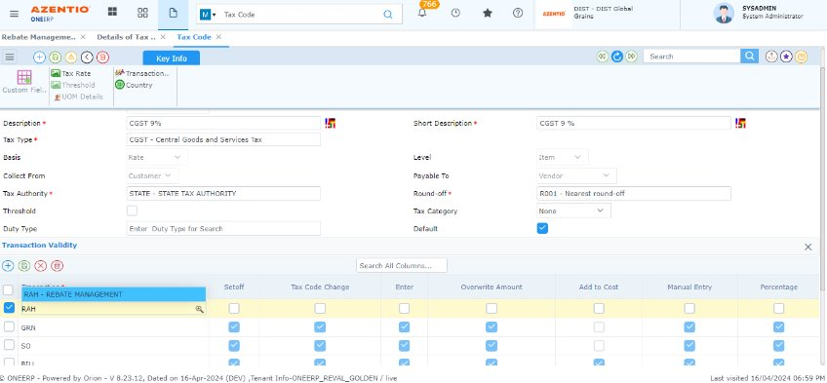
- Under Configurator -> RBTP (Rebate processing) -> More options -> Sales Tax and VAT Related->
  - Calculated TED on save Y/N should be - Ticked,
  - PULL TED TYPE- Automatic,
  - Recalculate TED Type-Automatic
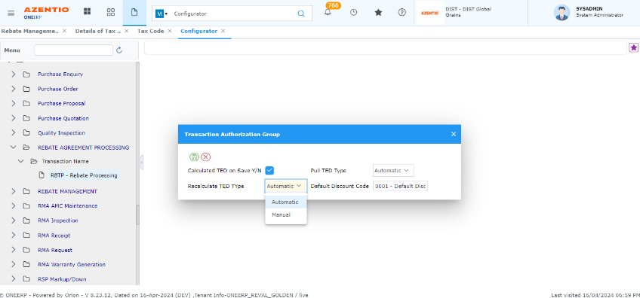

Tax calculation
- In Rebate Management, there’s a Tax block hyperlink under Billing Details. Depending on the subtype selected, tax can be added at the line-item level.
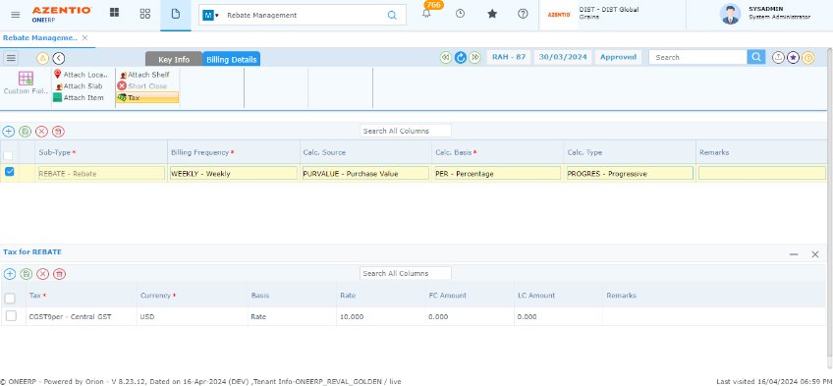
- In the Rebate Processing screen, clicking “Pull Details” will show the automatically calculated tax details based on the tax codes selected in the Rebate Management transaction.
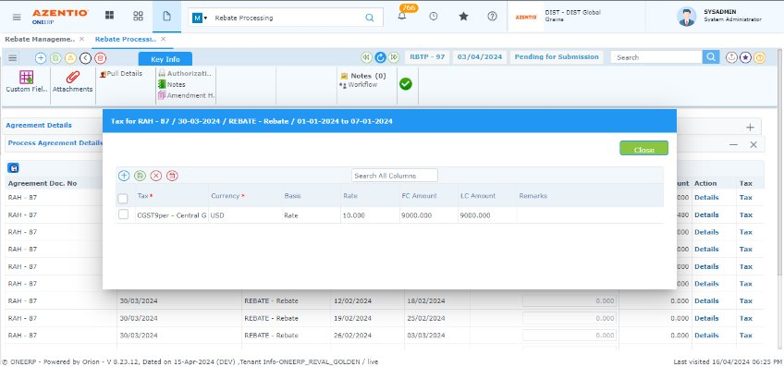
For these tax details, based on the party type, the system generates a Credit Note (FICN) for customers or a Debit Note (FIDN) for suppliers

3. Price list

3.1 Price List Type (Master)
Price List Type Master captures the type of the Price List applicable to the sale items in the organization.

3.2 Company price list (Master)
The master allows the user to create price lists for a set of items. These price lists are specific to the company that created them. Therefore, the price list-currency code combination uniquely identifies the price lists. The user is allowed to attach the company price list to the customer master and at the transaction setup.

Hyperlink | Description
Custom Fields | Custom field refers to a user-defined field that can be added to capture specific data that might not be accommodated by default fields.
Item Details | Allows the user to define the items and date-wise break-up of prices. It is vital that the Item Code-Grade Code-UOM Code combination is unique to each price list
Copy/Calculate | Allows to copy an existing price list into a new one to eliminate duplication of data entry

3.3 Customer specific price list (Master)
The Customer Price List facilitates you to create a customer-specific price list compared to a generic one. Like a general price list, the user is allowed to create a customer price list in multiple currencies. Likewise, the Customer Price List needs a unique Item Code-Grade Code-UOM Code combination.

Hyperlink | Description
Custom Fields | Custom field refers to a user-defined field that can be added to capture specific data that might not be accommodated by default fields.
Item Details | Allows the user to define the items and date-wise break-up of prices. It is vital that the Item Code-Grade Code-UOM Code combination is unique to each price list
Copy/Calculate | Allows to copy an existing price list into a new one to eliminate duplication of data entry

3.4 General price list update (Master)
The master allows the user to create price lists for a set of items. These price lists are specific to the company that created them. Therefore, the price list-currency code combination uniquely identifies the price lists.

Price List Update - Mobility Solution
Functional Features:
- Company and customer price lists are shown based on type selected and the price can be updated and generated.
- After Generation, the document is available inside the price list dashboard, once the records approved only the price change will be reflected to ONEERP.

3.5 Price display from price list query (Query)
Price Display from Price List Query screen helps to display price of an item based on Price list.

4. OWN Delivery Dashboard

4.1 Vehicle/truck details (Master)
Capture the details of vehicle (truck) that is used for delivery.

4.2 Driver Profile (Master)
The Driver Profile screen facilitates to captures the truck driver’s personal and official details.

Hyperlink | Description
License Details | Captures various type of License the driver holds, along with the License Code, Place of Issue, and Expiry Date
Applicable Company | The applicable companies are mapped for the driver
Non-Availability  of driver | Capture details of ‘Non-Availability of the ‘Driver’ and the reason for the same. Option is available to make the driver inactive so that the driver can’t be planned for any delivery

4.3 ODD Route (Master)
ODD route master helps to add route and route details.

4.4 Assign Truck to Driver (Master)
This screen enables the user to link the truck ‘Driver’ and ‘Vehicle Master’ based on date range.

4.5 Truck down time (Master)
Truck Downtime master allows to add the downtime for trucks or vehicles used in own delivery dashboard for a particular From date & To date, Trip From & Trip To with reason.

4.6 Own delivery dashboard (Processing)
This screen enables you to sense real time demand of your Organizational units, and create an organization with higher service levels, saving you time, resolves goods delivery problems, and increasing overall customer satisfaction.

5. Credit Control

5.1 Credit control level (Master)
The Credit Control Level master is used to define various credit control levels at a transaction. This master is used only if the customer involved in a transaction requires credit control. This master facilitates provision of grace amount when the credit utilized is greater than the credit limit allotted to the customer (as defined in the Customer Master). An authorized user is permitted to increase the credit control level in the SO and sales invoice transactions.

Hyperlink | Description
User Details | Allows to add User details

5.2 Credit control Rule (Master)
During creation of a SO, DN or INV for a customer, the application validates the previous credit period and value for the customer. The Error/Warning/Ignore parameter is set in the Credit Control Rules.

5.3 Credit Control Console (Processing)
The Credit Control Console is used to Approve and Process the credit control transaction.

6. Sales Commission Definition

6.1 Sales commission Definition (Master)
Sales commission Definition master screen helps to define sales commission percent-based value/quantity and define validity date

6.2 Sales Commission Dashboard (Processing)
This screen enables us to process sales commission after sales invoice and payment. After processing sales commission, it will be reflected in Sales commission query screen

6.3 Sales commission query (Query)
Sales commission query screen displays the commission percentage and commission amount based on salesman and sales target.

7. Leads & Opportunities Management

7.1 Process pack

Scenarios

- Leads-Opportunities & quotes-Order Confirmation-Delivery Note-Invoice to Customer-Credit Note
- Opportunities & quotes-Order Confirmation-Delivery Note-Invoice to Customer-Credit Note
- Order Confirmation-Delivery Note-Invoice to Customer-Credit Note
- Order Confirmation-Invoice to Customer
- Invoice to Customer-Credit Note
- Credit Note

7.2 Prospect master
Prospect master helps identify, approach, and successfully turn prospects into paying Customer. This screen helps to create prospect customers with their address details, contact type and there is an option in this screen to convert prospect to customer.

Hyperlink | Description
Custom Fields | Custom field refers to a user-defined field that can be added to capture specific data that might not be accommodated by default fields.
Analysis | Captures the analysis data
Address | Captures the address details
Hobbies | Captures the hobbies
Retail Contact Info | Facilitates to add retail contact information
Retail Contact | Facilitates to add retail contact details
Corporate Contact Information | Facilitates to add corporate contact information
Corporate Contact | Facilitates to add corporate contact details
Employee Details | Facilitates to add employee Details

7.3 Sales Team Activity Updates (non-Mandatory screen in process pack acts an reference for sales team)-Transaction
This screen will help to capture salesman daily activities and associated attributes.
Hyperlink | Description
Custom Fields | Custom field refers to a user-defined field that can be added to capture specific data that might not be accommodated by default fields.
Attachments | To attach documents that is related to the transaction.
Authorization | View the details of the approvers for the transaction
Notes | Notes feature allows users to add personalized comments, including their automatically retrieved username. These comments can then be printed directly onto the document.
Amendment History | view transaction amendment history details if any
Prospect Visited | Specify the prospect visited details
Customer Visited | Specify the customer visited details
Enquiry/Lead Reference | Shows the Reference Document number from where the Enquiry/Lead is created.
Opportunities/Quotes Reference | Shows the Reference Document number from where the Opportunities/Quotes is created.
Amendment | User can Amend the transaction by giving the reason
Sticky Notes | Sticky notes is a feature where comments/remarks can be added & assigned to users to take necessary actions on the same
Workflow | Displays the Current Workflow status as Pending, Current, Completed.
Custom Fields (Item details) | Custom field refers to a user-defined field that can be added to capture specific data that might not be accommodated by default fields.

Transaction Parameter: Sales team activity
Transaction parameter Type | Parameter | Value | Description
Documentflow | Amendment after approval | Yes/No | If Amendment option is required after approval, then the parameter can be set as 'Yes', if Amendment after approval is not needed set as 'No'
Documentflow | Authorization Reqd. | Yes/No | If Authorization is required then it can be set as Yes, If the Authorization is not required then it can be changed as No
Documentflow | Authorization Type | 1 Horizontal Any, 2 Horizontal All,3 Vertical All,4 Vertical Bypass, 5 Value Based | Authorization Type can be set from the following 5 options based on user preference. 1 Horizontal Any,2 Horizontal All,3 Vertical All,4 Vertical Bypass,5 Value Based
Documentflow | Exception Based Approval Yes / No | Yes/No | If Exception Based on Approval is required then Yes parameter can be selected, like wise If Exception Based on Approval is not required select No
Documentflow | Print Before/After/Any Approval | 1 Printing Before Approval, 2 Printing After Approval, 3 Printing Anytime Approval | If Print Before/After/Any Approval is based on the selection of following parameter - 1 Printing Before Approval, 2 Printing After Approval, 3 Printing Anytime Approval
Documentflow | Reject to the Previous Level | Previous Level | Rejection level can be selected as Beginning level or Previous level
Documentflow | Reject to the Beginning | Beginning Level | Rejection level can be selected as Beginning level or Previous level
Documentflow | Send Mail for Approval on Submit | Yes/No | If mail has to be sent for approval after submission, then the parameter can be set as Yes, if not required it can be No
Documentflow | Modification required after Submission Yes/ No | Yes/No | If modification required after Submission, then the parameter can be set as Yes, if not required it can be No
Documentflow | Submit for Approval Required Yes / No. | Yes/No | If submit for approval is required then the parameter can be set as Yes, if not it can be No.
Finance | Buying/Selling Rate | 1 Buying, 2 Selling Rate | Select the rate type required from the following 1 Buying, 2 Selling
Finance | Rate in txn UOM | 1 Rate in Txn Uom,2 Rate in Base UOM | Rate in transaction UOM is based on the selection of following parameter - 1 Rate in Txn Uom,2 Rate in Base UOM
Generic | Workflow based on Mapping (Manual) or Criteria (Automatic) | 1 Manual Workflow, 2 Automatic Workflow | Workflow mapping can be selected based on Manual or Automatic
Generic | Attach DMS documents in Workflow mail alert | Yes/No | Attach DMS documents in Workflow mail alert option is required then the parameter can be Yes, if not required it can be No
Generic | Validate documents uploaded in DMS or not during Workflow submit | Yes/No | Validate documents uploaded in DMS or not during Workflow submit, to enable this option the parameter has to be set as Yes. If not needed it can be no
Generic | Document No Gen. at | 1 Company, 2 Document Source Location, 3 Manual | Document number generation can be selected from the following (1 Company, 2 Document Source Location, 3 Manual)
Generic | Document No Gen.at | 1 Company, 2 Document Source Location, 3 Manual | Document number generation can be selected from the following (1 Company, 2 Document Source Location, 3 Manual)
Generic | Document Upload After Approval Yes/No | Yes/No | If document upload option is required after approval, then the parameter can be set as Yes, if not required it can be set as No
Generic | Modify Notes After Approval Yes/No | Yes/No | If modification of Notes after approval is required then the parameter can set as Yes, if not required it can be set as No
Generic | Workflow Code | Workflow Code (STDWF) | Workflow code needed to be selected as standard workflow

7.4 Leads (Transaction)
Leads are potential customers who have taken some action that indicates their potential interest. This action could be like Enquiring About the Product availability and Price of the product.
Hyperlink | Description
Custom Fields | Custom field refers to a user-defined field that can be added to capture specific data that might not be accommodated by default fields.
More | Captures the optional information for header details
Terms | Terms is a feature where specific details or exceptions relevant to this record, ensuring both parties are on the same page
Reference | Shows the Reference Document number from where the Purchase Enquiry is created.
Attachments | To attach documents that is related to the transaction.
Authorization | View the details of the approvers for the transaction
Notes | Notes feature allows users to add personalized comments, including their automatically retrieved username. These comments can then be printed directly onto the document.
Amendment History | view transaction amendment history details if any
Sticky Notes | Sticky notes is a feature where comments/remarks can be added & assigned to users to take necessary actions on the same
Workflow | Displays the Current Workflow status as Pending, Current, Completed.
Custom Fields (Item details) | Custom field refers to a user-defined field that can be added to capture specific data that might not be accommodated by default fields.
Delivery Schedule | Captures Delivery Schedule of order. This is required in case the System generated Delivery schedule needs to be broken in to multiple levels
Alternate Item | Facility to record items that alternate with/replace the item code entered during transactions.
Short close | When an item runs out of stock

Transaction Parameter: Leads
Transaction parameter Type | Parameter | Value | Description
Auto | Default Vehicle Price List | Default Vehicle Price List | This parameter allows to set default vehicle price list
Auto | Search Vehicle price list level | 1 Search Vehicle Price in Trans Currency, 2 Search Vehicle Price in Base Currency | Search Vehicle price list level is based on the following parameters-1 Search Vehicle Price in Trans Currency, 2 Search Vehicle Price in Base Currency
Documentflow | Allow Multiple Document Pulling | Yes/No | Multiple Document Pulling option is needed then parameter can be set as 'Yes', Multiple Document Pulling not required set as 'No'
Documentflow | Amendment after approval | Yes/No | If Amendment option is required after approval, then the parameter can be set as 'Yes', if Amendment after approval is not needed set as 'No'
Documentflow | Authorization Reqd. | Yes/No | If Authorization is required then it can be set as Yes, If the Authorization is not required then it can be changed as No
Documentflow | Authorization Type | 1 Horizontal Any, 2 Horizontal All,3 Vertical All,4 Vertical Bypass, 5 Value Based | Authorization Type can be set from the following 5 options based on user preference. 1 Horizontal Any,2 Horizontal All,3 Vertical All,4 Vertical Bypass,5 Value Based
Documentflow | Exception Based Approval Yes / No | Yes/No | If Exception Based on Approval is required then Yes parameter can be selected, like wise If Exception Based on Approval is not required select No
Documentflow | Reject to the Previous Level | Previous Level | Rejection level can be selected as Beginning level or Previous level
Documentflow | Reject to the Beginning | Beginning Level | Rejection level can be selected as Beginning level or Previous level
Documentflow | Send Mail for Approval on Submit | Yes/No | If mail has to be sent for approval after submission, then the parameter can be set as Yes, if not required it can be No
Documentflow | Modification required after Submission Yes/ No | Yes/No | If modification required after Submission, then the parameter can be set as Yes, if not required it can be No
Documentflow | Submit for Approval Required Yes / No. | Yes/No | If submit for approval is required then the parameter can be set as Yes, if not it can be No.
Excise | Edit Assessable Rate - Yes | Yes/No | If edit assessable rate option is required then the parameter as to be selected as Yes, if not required No
Excise | Edit Assessable Rate - No | Yes/No | If edit assessable rate option is required then the parameter as to be selected as Yes, if not required No
Excise | Excise Required Yes | Yes/No | If excise required then the parameter as to be selected as Yes, if not required No
Excise | Excise Required No | Yes/No | If excise required then the parameter as to be selected as Yes, if not required No
Finance | Buying/Selling Rate | 1 Buying, 2 Selling Rate | Select the rate type required from the following 1 Buying, 2 Selling
Finance | Default Price List | Default Price List | This parameter enables to set default price list
Finance | Discount Required YN | 1 Discount Not Required, 2 Discount Required | If discount required then the parameter as to be selected as discount required, if not required select discount not required
Finance | Price List TED pulling based on Customer master Search level Yes/No | Yes/No | If price list TED pulling based on customer master search level is required then the parameter as to be selected as Yes, if not required No
Finance | Price List TED pulling based on Customer master Search level Yes/N0 | Yes/No | If price list TED pulling based on customer master search level is required then the parameter as to be selected as Yes, if not required No
Finance | Pull expenses from ref doc. | Yes/No | If pull expenses from reference document is required then the parameter as to be selected as Yes, if not required No
Finance | Redisplay price on Item code change | Yes/No | If redisplay price on Item code change is required then the parameter as to be selected as Yes, if not required No
Finance | Search price list level | 1 Search Vehicle Price in Trans Currency, 2 Search Vehicle Price in Base Currency | Search price list level is based on the following parameter selection- 1 Search Price in Trans Currency, 2 Search Price in Base Currency, 3 Search in Trans Then Base Curr
Generic | Workflow based on Mapping (Manual) or Criteria (Automatic) | 1 Manual Workflow, 2 Automatic Workflow | Workflow mapping can be selected based on Manual or Automatic
Generic | Default Currency / UOM From | 1 Reference Document, 2 Sales Enquiry | Default Currency / UOM From is based on the selection of the following parameter- 1 Reference Document, 2 Sales Enquiry
Generic | Attach DMS documents in Workflow mail alert | Yes/No | Attach DMS documents in Workflow mail alert option is required then the parameter can be Yes, if not required it can be No
Generic | Validate documents uploaded in DMS or not during Workflow submit | Yes/No | Validate documents uploaded in DMS or not during Workflow submit, to enable this option the parameter has to be set as Yes. If not needed it can be no
Generic | Upload default txn document in DMS after final approval | Yes/No | Upload default transaction document in DMS after final approval, to enable this option the parameter has to be set as Yes. If not needed it can be no
Generic | Document No Gen. at | 1 Company, 2 Document Source Location, 3 Manual | Document number generation can be selected from the following (1 Company, 2 Document Source Location, 3 Manual)
Generic | Document Upload After Approval Yes/No | Yes/No | If document upload option is required after approval, then the parameter can be set as Yes, if not required it can be set as No
Generic | Modify Flex After Submit/Approval Yes/No | Yes/No | If modification of Flex fields details after submit/approval is required then the parameter can set as Yes, if not required it can be set as No
Generic | Modify Notes After Approval Yes/No | Yes/No | If modification of Notes after approval is required then the parameter can set as Yes, if not required it can be set as No
Generic | Prospect Quotation - Yes/No | Yes/No | If prospect quotation is required then the parameter can set as Yes, if not required it can be set as No
Generic | Transaction Class | Normal, Vehicle | Transaction class can be selected from the following two field, Normal / Vehicle
Generic | Workflow Code | Workflow Code (STDWF) | Workflow code needed to be selected as standard workflow
Inventory | Non-Stock required | Yes/No | If non-stock item is required then the parameter can be set as Yes, if not required it can be No
Inventory | Pull Stock/Non stock/Both | 1 Pull Only Stock Items, 2 Pull Only Non-Stock Items, 3 Pull Stock and Non-Stock Items | Type of stock to be pulled is based on the selection of the following parameter 1 Pull Only Stock Items, 2 Pull Only Non-Stock Items, 3 Pull Stock and Non-Stock Items
Inventory | Superseded Items | 1 IGNORE, 2 WARNING, 3 STOP | For superseded items error pops, up (1 IGNORE, 2 WARNING, 3 STOP based) on the selection of parameter
Inventory | UOM can be modified | Yes/No | If modification of UOM is required then the parameter can be set as Yes, if not required it can be No
Inventory | User wise control required to modify Exchange Rate (Y/N) | Yes/No | If user wise control required to modify Exchange Rate, then the parameter can be set as Yes, if not required it can be No

7.5 Opportunities and Quotes (Transaction)
Opportunity and quotes refer to a potential sales deal or a chance to convert a lead or prospect into a paying customer. When a lead has been Confirmed Quote can be given, and there's a realistic chance of making a sale it is considered an opportunity and quotes

Hyperlink | Description
Custom Fields | Custom field refers to a user-defined field that can be added to capture specific data that might not be accommodated by default fields.
More | Captures the optional information for header details
Terms | Terms is a feature where specific details or exceptions relevant to this record, ensuring both parties are on the same page
Reference | Shows the Reference Document number from where the Purchase Enquiry is created.
Attachments | To attach documents that is related to the transaction.
Authorization | View the details of the approvers for the transaction
Notes | Notes feature allows users to add personalized comments, including their automatically retrieved username. These comments can then be printed directly onto the document.
Tax, Expense, Discount | Specify the Tax, Expense and Discount details as applicable
Amendment History | view transaction amendment history details if any
Total | View document value details based on the defined currency type
Sticky Notes | Sticky notes is a feature where comments/remarks can be added & assigned to users to take necessary actions on the same
Workflow | Displays the Current workflow status as Pending, Current, Completed.
Custom Fields  (Item details) | Custom field refers to a user-defined field that can be added to capture specific data that might not be accommodated by default fields.
Tax, Expense, Discount | Specify the Tax, Expense and Discount details as applicable
Delivery Schedule | Captures Delivery Schedule of order. This is required in case the System generated Delivery schedule needs to be broken in to multiple levels
Alternate Item | Facility to record items that alternate with/replace the item code entered during transactions.
Short close | When an item runs out of stock

Transaction Parameter: Opportunities and quotes
Transaction parameter Type | Parameter | Value | Description
Auto | Default Vehicle Price List | Default Vehicle Price List | This parameter allows to set default vehicle price list
Auto | Search Vehicle price list level | 1 Search Vehicle Price in Trans Currency, 2 Search Vehicle Price in Base Currency | Search Vehicle price list level is based on the following parameters-1 Search Vehicle Price in Trans Currency, 2 Search Vehicle Price in Base Currency
Documentflow | Allow Multiple Document Pulling | Yes/No | Multiple Document Pulling option is needed then parameter can be set as 'Yes', Multiple Document Pulling not required set as 'No'
Documentflow | Amendment after approval | Yes/No | If Amendment option is required after approval, then the parameter can be set as 'Yes', if Amendment after approval is not needed set as 'No'
Documentflow | Authorization Reqd. | Yes/No | If Authorization is required then it can be set as Yes, If the Authorization is not required then it can be changed as No
Documentflow | Authorization Type | 1 Horizontal Any, 2 Horizontal All,3 Vertical All,4 Vertical Bypass, 5 Value Based | Authorization Type can be set from the following 5 options based on user preference. 1 Horizontal Any,2 Horizontal All,3 Vertical All,4 Vertical Bypass,5 Value Based
Documentflow | Exception Based Approval Yes / No | Yes/No | If Exception Based on Approval is required then Yes parameter can be selected, like wise If Exception Based on Approval is not required select No
Documentflow | Reject to the Beginning | Beginning Level | Rejection level can be selected as Beginning level or Previous level
Documentflow | Reject to the Previous Level | Previous Level | Rejection level can be selected as Beginning level or Previous level
Documentflow | Send Mail for Approval on Submit | Yes/No | If mail has to be sent for approval after submission, then the parameter can be set as Yes, if not required it can be No
Documentflow | Modification required after Submission Yes/ No | Yes/No | If modification required after Submission, then the parameter can be set as Yes, if not required it can be No
Documentflow | Submit for Approval Required Yes / No. | Yes/No | If submit for approval is required then the parameter can be set as Yes, if not it can be No.
Excise | Edit Assessable Rate - No | Yes/No | If edit assessable rate option is required then the parameter as to be selected as Yes, if not required No
Excise | Edit Assessable Rate - Yes | Yes/No | If edit assessable rate option is required then the parameter as to be selected as Yes, if not required No
Excise | Excise Required No | Yes/No | If excise required then the parameter as to be selected as Yes, if not required No
Excise | Excise Required Yes | Yes/No | If excise required then the parameter as to be selected as Yes, if not required No
Finance | Buying/Selling Rate | 1 Buying, 2 Selling Rate | Select the rate type required from the following 1 Buying, 2 Selling
Finance | Default Price List | Default Price List | This parameter enables to set default price list
Finance | Discount Required YN | 1 Discount Not Required,2 Discount Required | If discount required then the parameter as to be selected as discount required, if not required select discount not required
Finance | Price List TED pulling based on Customer master Search level Yes/No | Yes/No | If price list TED pulling based on customer master search level is required then the parameter as to be selected as Yes, if not required No
Finance | Price List TED pulling based on Customer master Search level Yes/NO | Yes/No | If price list TED pulling based on customer master search level is required then the parameter as to be selected as Yes, if not required No
Finance | Pull expenses from ref doc. | Yes/No | If pull expenses from reference document is required then the parameter as to be selected as Yes, if not required No
Finance | Redisplay price on Item code change | Yes/No | If redisplay price on Item code change is required then the parameter as to be selected as Yes, if not required No
Finance | Search price list level | 1 Search Vehicle Price in Trans Currency, 2 Search Vehicle Price in Base Currency | Search price list level is based on the following parameter selection- 1 Search Price in Trans Currency, 2 Search Price in Base Currency, 3 Search in Trans Then Base Curr
Generic | Workflow based on Mapping (Manual) or Criteria (Automatic) | 1 Manual Workflow, 2 Automatic Workflow | Workflow mapping can be selected based on Manual or Automatic
Generic | Default Currency / UOM From | 1 Reference Document, 2 Sales Enquiry | Default Currency / UOM From is based on the selection of the following parameter- 1 Reference Document, 2 Sales Enquiry
Generic | Attach DMS documents in Workflow mail alert | Yes/No | Attach DMS documents in Workflow mail alert option is required then the parameter can be Yes, if not required it can be No
Generic | Validate documents uploaded in DMS or not during Workflow submit | Yes/No | Validate documents uploaded in DMS or not during Workflow submit, to enable this option the parameter has to be set as Yes. If not needed it can be no
Generic | Upload default txn document in DMS after final approval | Yes/No | Upload default transaction document in DMS after final approval, to enable this option the parameter has to be set as Yes. If not needed it can be no
Generic | Document No Gen. at | 1 Company, 2 Document Source Location, 3 Manual | Document number generation can be selected from the following (1 Company, 2 Document Source Location, 3 Manual)
Generic | Document Upload After Approval Yes/No | Yes/No | If document upload option is required after approval, then the parameter can be set as Yes, if not required it can be set as No
Generic | Modify Flex After Submit/Approval Yes/No | Yes/No | If modification of Flex fields details after submit/approval is required then the parameter can set as Yes, if not required it can be set as No
Generic | Modify Notes After Approval Yes/No | Yes/No | If modification of Notes after approval is required then the parameter can set as Yes, if not required it can be set as No
Generic | Prospect Quotation - Yes/No | Yes/No | If prospect quotation is required then the parameter can set as Yes, if not required it can be set as No
Generic | Transaction Class | Normal, Vehicle | Transaction class can be selected from the following two field, Normal / Vehicle
Generic | Workflow Code | Workflow Code (STDWF) | Workflow code needed to be selected as standard workflow
Inventory | Non-Stock required | Yes/No | If non-stock item is required then the parameter can be set as Yes, if not required it can be No
Inventory | Pull Stock/Non stock/Both | 1 Pull Only Stock Items, 2 Pull Only Non-Stock Items, 3 Pull Stock and Non-Stock Items | Type of stock to be pulled is based on the selection of the following parameter 1 Pull Only Stock Items, 2 Pull Only Non-Stock Items, 3 Pull Stock and Non-Stock Items
Inventory | Superseded Items | 1 IGNORE, 2 WARNING, 3 STOP | For superseded items error pops, up (1 IGNORE, 2 WARNING, 3 STOP based) on the selection of parameter
Inventory | UOM can be modified | Yes/No | If modification of UOM is required then the parameter can be set as Yes, if not required it can be No
Inventory | User wise control required to modify Exchange Rate (Y/N) | Yes/No | If user wise control required to modify Exchange Rate, then the parameter can be set as Yes, if not required it can be No

7.6 Transaction-Sales order, Delivery note, Invoice, credit note (Leads and Opportunities Management)
Existing functionality is the same for the following as local sales and export sales

8. Cost To Serve and Apportionment
8.1 Cost Basis (Master)
Cost basis refers to type in which costs are calculated (Example: Proportionate, Formula)

8.2 Cost Components (Master)
This screen helps to configure one or multiple cost components sets​.it is an User Configurable list of unique combination of Indirect expense accounts that needs to be planned (Rent, Salaries, Utilities.)​
Configure list of items for which cost processing to be done as required by the business.
Hyperlink | Description
Custom Fields | Custom field refers to a user-defined field that can be added to capture specific data that might not be accommodated by default fields.
Criteria Account | Facilitates to add Criteria Account Details
Criteria Item | Facilitates to add Criteria Item Details

8.3 Inventory adjustments (Setup)
Inventory adjustments setup refers to the accounting or operational modifications made to accurately reflect the value of inventory within the supply chain and its associated costs. These adjustments are essential in cost-to-serve analysis as they impact on the overall cost structure of serving customers and provide a clearer picture of the expenses incurred in managing inventory. Financial setup for Inventory adjustment account has to be done in this screen by entering required details with its main account code.

8.4 Adjusted cost allocated (Setup)
Adjusted cost allocated setup refers to the refined or modified costs that have been allocated or assigned to different activities, departments, or segments within an organization. These adjustments are made to better reflect the actual costs associated with serving customers, managing operations, and delivering products or services. Financial setup for adjusted cost account has to be done in this screen by entering required details with its main account code.

8.5 Cost To Serve Allocation Details (Transaction)
Cost-to-serve allocation refers to the process of assigning or allocating specific costs to the various activities or components within the supply chain that contribute to serving customers. It involves determining how different costs are apportioned or distributed across the supply chain to understand the expenses associated with fulfilling customer demands and delivering products or services. This screen has a Provision to pull account code wise actual GL amount for any closed period​. Provision to round-off or modify the final amount to be processed.

Hyperlink | Description
Custom Fields | Custom field refers to a user-defined field that can be added to capture specific data that might not be accommodated by default fields.
Attachments | To attach documents that is related to the transaction.
Authorization | View the details of the approvers for the transaction
Notes | Notes feature allows users to add personalized comments, including their automatically retrieved username. These comments can then be printed directly onto the document.
Amendment History | view transaction amendment history details if any
Sticky Notes | Sticky notes is a feature where comments/remarks can be added & assigned to users to take necessary actions on the same
Workflow | Displays the Current Workflow status as Pending, Current, Completed.
Custom Fields  (Item details) | Custom field refers to a user-defined field that can be added to capture specific data that might not be accommodated by default fields.

Transaction Parameter: Cost to serve allocation detail
Transaction parameter Type | Parameter | Value | Description
Documentflow | Amendment after approval | Yes/No | If Amendment option is required after approval, then the parameter can be set as 'Yes', if Amendment after approval is not needed set as 'No'
Documentflow | Authorization Reqd. | Yes/No | If Authorization is required then it can be set as Yes, If the Authorization is not required then it can be changed as No
Documentflow | Authorization Type | 1 Horizontal Any, 2 Horizontal All,3 Vertical All,4 Vertical Bypass, 5 Value Based | Authorization Type can be set from the following 5 options based on user preference. 1 Horizontal Any,2 Horizontal All,3 Vertical All,4 Vertical Bypass,5 Value Based
Documentflow | Exception Based Approval Yes / No | Yes/No | If Exception Based on Approval is required then Yes parameter can be selected, like wise If Exception Based on Approval is not required select No
Documentflow | Print Before/After/Any Approval | 1 Printing Before Approval, 2 Printing After Approval, 3 Printing Anytime Approval | If Print Before/After/Any Approval is based on the selection of following parameter - 1 Printing Before Approval, 2 Printing After Approval, 3 Printing Anytime Approval
Documentflow | Reject to the Previous Level | Previous Level | Rejection level can be selected as Beginning level or Previous level
Documentflow | Reject to the Beginning | Beginning Level | Rejection level can be selected as Beginning level or Previous level
Documentflow | Send Mail for Approval on Submit | Yes/No | If mail has to be sent for approval after submission, then the parameter can be set as Yes, if not required it can be No
Documentflow | Modification required after Submission Yes/ No | Yes/No | If modification required after Submission, then the parameter can be set as Yes, if not required it can be No
Documentflow | Submit for Approval Required Yes / No. | Yes/No | If submit for approval is required then the parameter can be set as Yes, if not it can be No.
Finance | Buying/Selling Rate | 1 Buying, 2 Selling Rate | Select the rate type required from the following 1 Buying, 2 Selling
Finance | Financial Transaction Code | Financial Transaction Code | Financial Transaction code selection is based on this parameter
Finance | Rate in txn UOM | 1 Rate in Txn Uom,2 Rate in Base UOM | Rate in transaction UOM is based on the selection of following parameter - 1 Rate in Txn Uom,2 Rate in Base UOM
Generic | Workflow based on Mapping (Manual) or Criteria (Automatic) | 1 Manual Workflow, 2 Automatic Workflow | Workflow mapping can be selected based on Manual or Automatic
Generic | Attach DMS documents in Workflow mail alert | Yes/No | Attach DMS documents in Workflow mail alert option is required then the parameter can be Yes, if not required it can be No
Generic | Validate documents uploaded in DMS or not during Workflow submit | Yes/No | Validate documents uploaded in DMS or not during Workflow submit, to enable this option the parameter has to be set as Yes. If not needed it can be no
Generic | Document No Gen. at | 1 Company, 2 Document Source Location, 3 Manual | Document number generation can be selected from the following (1 Company, 2 Document Source Location, 3 Manual)
Generic | Document No Gen.at | 1 Company, 2 Document Source Location, 3 Manual | Document number generation can be selected from the following (1 Company, 2 Document Source Location, 3 Manual)
Generic | Document Upload After Approval Yes/No | Yes/No | If document upload option is required after approval, then the parameter can be set as Yes, if not required it can be set as No
Generic | Modify Notes After Approval Yes/No | Yes/No | If modification of Notes after approval is required then the parameter can set as Yes, if not required it can be set as No
Generic | Workflow Code | Workflow Code (STDWF) | Workflow code needed to be selected as standard workflow

8.6 Cost Apportioning (Processing)
Cost apportioning involves distributing or dividing indirect costs among different cost centers or activities within an organization. Indirect costs are expenses that are not directly attributable to a specific product, service, or department but contribute to the overall operation of the business. In this screen, Total indirect expense amount for the period would be allocated to all items that are sold during the period at quantity level on prorate basis.

9. Functional level link and Discount control matrix

9.1 Functional level link (Master)
Functional level link Master refers to the integration and connectivity between different functional modules or areas within the ONEERP. Functional level link involves connecting and coordinating the activities, data, and processes across various functional modules.

9.2 Discount control Matrix (Master)
Discount control matrix Master helps to regulate the application of discounts with in a business. It helps to define and organize the criteria, rules, and guidelines for offering discounts to customers or clients based on various factors. This matrix aids in maintaining consistency, ensuring profitability, and controlling discounting practices across different sales scenarios.

10. Inter company
When a business group has several companies, it is a common practice to do inter-company transactions. These transactions involve buying and selling across companies.
Let us take a scenario involving two group companies, Company 1 and Company 2: Company 2 wants to buy items from Company 1. Company 1 becomes a supplier and Company 2 is the customer.
As a customer, Company 2 raises the Purchase Order (PO) and creates the Sales Order (SO) in Company 1. Once Company 1 agrees to supply the items by accepting the Sales Order, it raises an invoice for Company 2, the customer. Next, the Goods Receipt Note (GRN) is created in Company 2.
10.1 Inter company operations transactions Prerequisite
- Create a Customer Code in Company 1. Set Company 1 as the applicable company for this Customer Code.
- Create a Supplier Code in Company 2. Set Company 2 as the applicable company for this Supplier Code.
- Attach the Supplier Code created in Company 2 to the ‘Inter Company Supplier Code’ field of Company master in Company 1.
- Attach the Customer Code in the ‘Inter Company Customer Code’ field of Company master in Company 2.

10.2 Inter company SO parameters
Enable the Inter Company SO button in PO transaction setup of Company 2 by setting the following parameters:
1.Inter Company SO Allowed Y/N to ‘Y’
2.Assign the Inter Company SO Item Type to one of these values:
1 – Stock Items
2 – Non Stock Items
3 – Both
3.Define the Inter Company PO Rate Source parameter to one of these values:
1 – Rate Contract
2 – Cost Group Level Cost
3 – Supplier Quotation

10.3 Inter-company GRN parameters
Enable Inter Company GRN button by setting up the following parameters in Sale Invoice transaction setup
1.Set the Invoice parameter to 3 – Invoice cum Delivery Note
2.Set the Inter Company GRN Allowed YN parameter to ‘Y’
3.Based on requirements, set the Inter Company GRN Pull TED Y/N parameter

11. Product Lifecycle Management (PLM)

Purpose
- Track the plan, stages, activities, and timelines for new product development from idea to launch.
- Capture projected sales volumes and compare them with actual sales.

Prerequisites
Under Value Sets (Navigation: Sales-Masters-Value Set), User defined values to be configured to proceed on PLM

Value set for PLM Planning – Stages
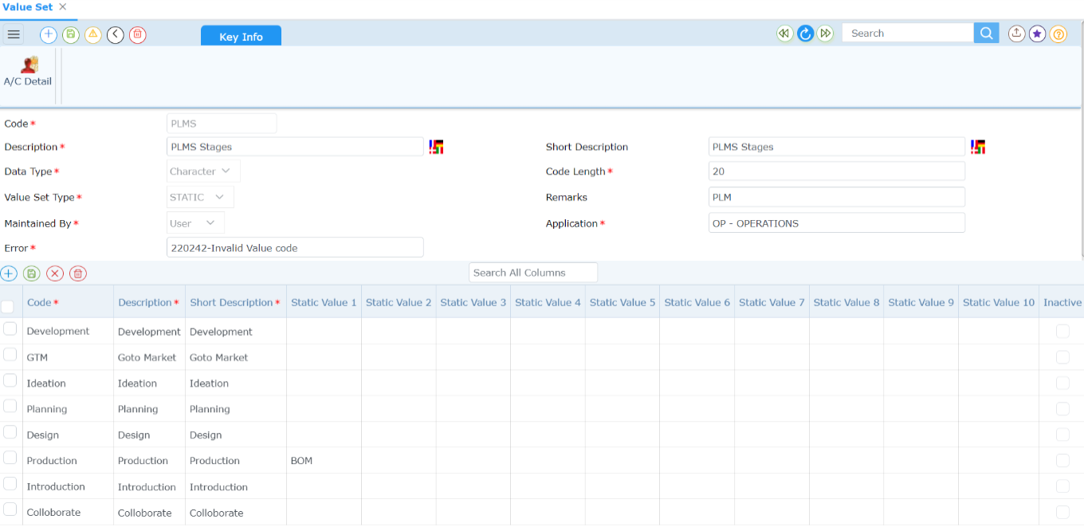

Value set for PLM Execution – Activity
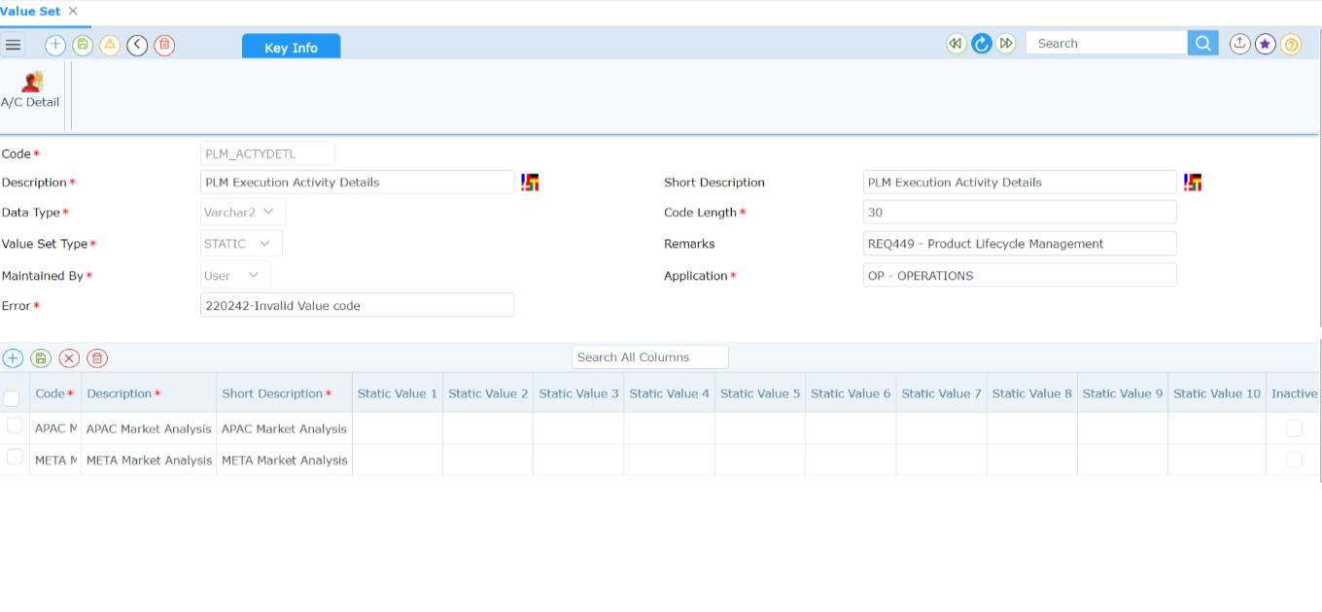

Value set for PLM Target – Life Cycle Stages
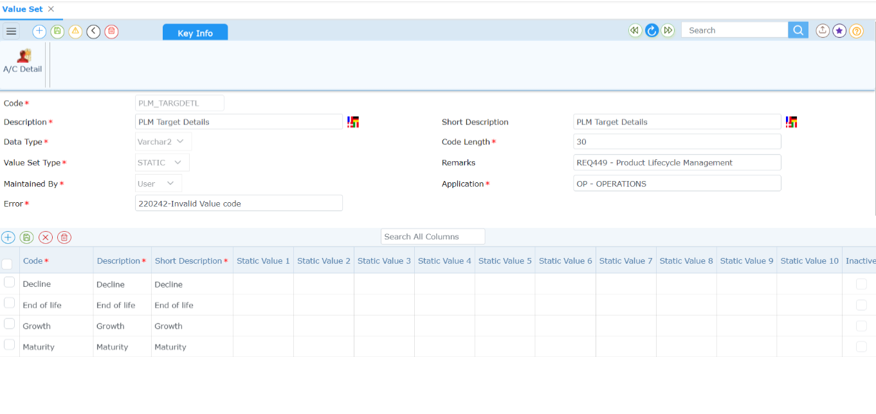

Transactions

PLM Plan
- Basic Key info details along with period (From & To Date) for PLM
- Appropriate Stages as required with planned timelines for the same
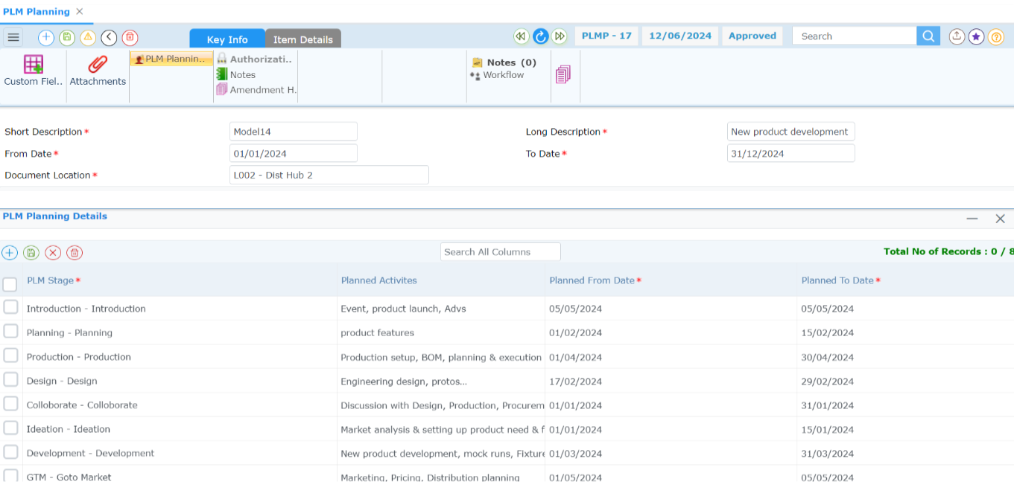
- Item details that are planned in this PLM
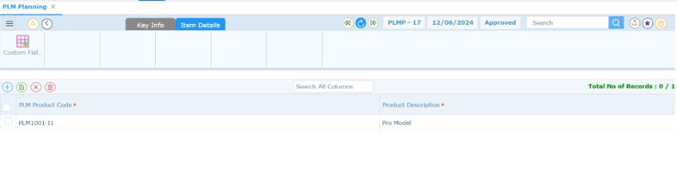

PLM Execution
- Basic Key info details fetched from Planning Phase
- Provision to capture actual timelines against the planned one
- One or multiple activity details under each execution stage (optional)
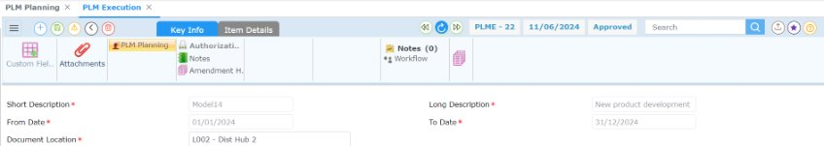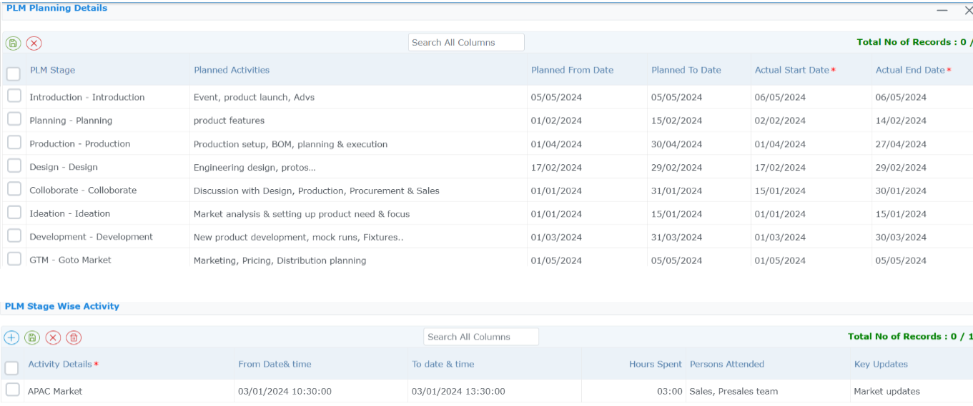
- Linking Item details from Master and Item Analysis view
- Production BOM created for new product development (only for Manufacturing)
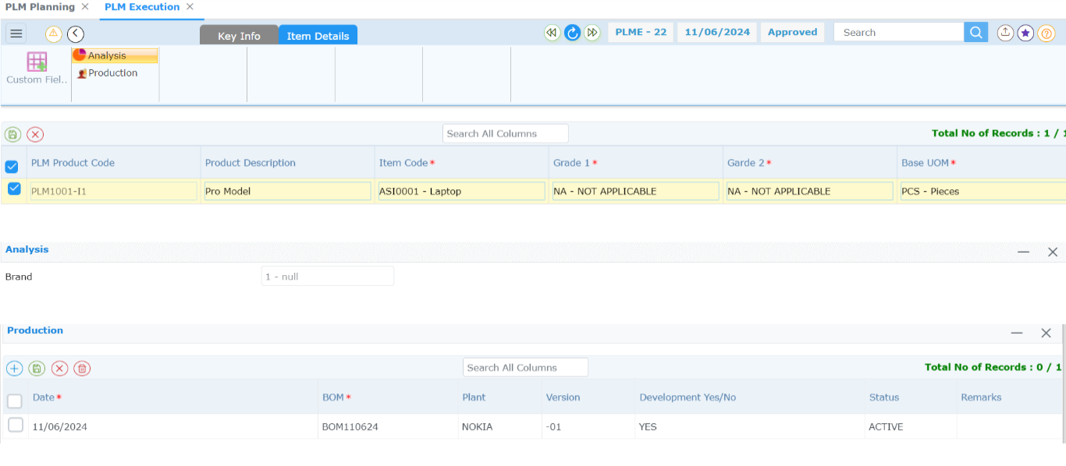

PLM Launch
- Basic Key info details fetched from Execution Phase
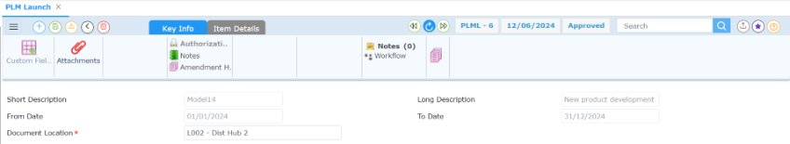
- Item wise Launch date
- Product Life Cycle tracking stages and projected sales volume along with period
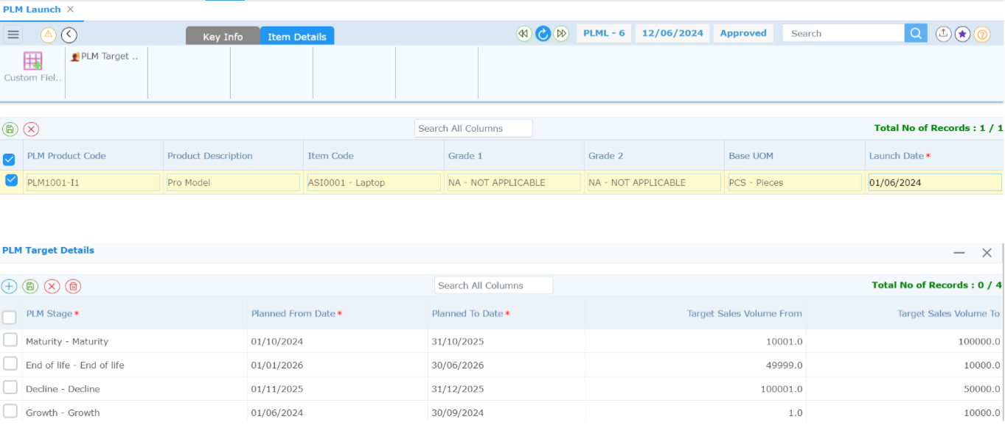

12. Customer Order Automation
Streamlining Order Processing with Bautomate (Ecosystem Partner)
Process Overview
Bautomate system automates customer order management by streamlining order intake, processing, and integration into ERP systems for efficient order fulfillment.
Order Intake & Data Processing
- Orders received via email, customer portals, or other channels are captured by the system.
- The bot processes order attachments, splits multi-order documents, extracts critical details using Optical Character Recognition (OCR), and validates the extracted data.
- Once validated, the system pushes the processed orders into the ERP for further actions.
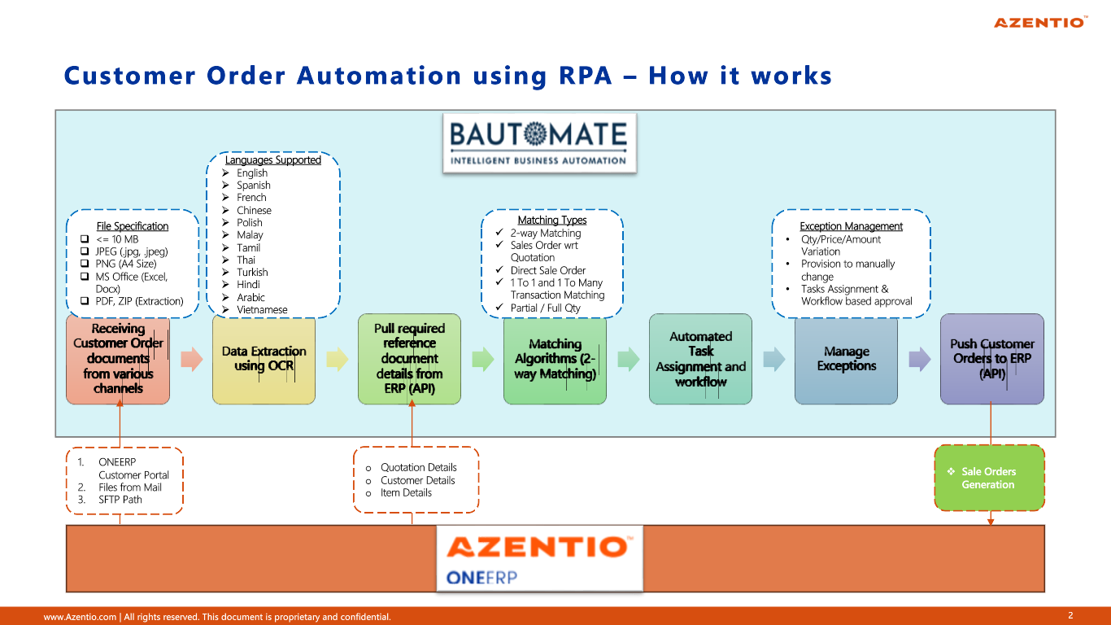

Matching & Validation
- Customer and Order Details Retrieval: Fetches customer profiles, previously shared Sales Quotations (if available), agreed pricing, and stock details from the ERP.
- Sales Quotation Matching: Matches orders against Sales Quotations to validate quantities, pricing, and terms.
- Discrepancy Handling:
- In case of mismatches with Sales Quotations, incorrect pricing, or unavailable stock, the system assigns a "Not matched" status.
- Discrepancies are flagged in red for manual review and resolution.

Benefits
End-to-End Automation: Streamlines order intake and ensures seamless integration into ERP systems with minimal manual intervention.
Enhanced Accuracy: Matching against Sales Quotations and inventory details reduces errors and ensures compliance with agreed terms.
Operational Efficiency: Accelerates the order-to-cash cycle, enabling faster order processing and fulfillment.
Customer Satisfaction: Accurate order processing and timely communication improve the customer experience.
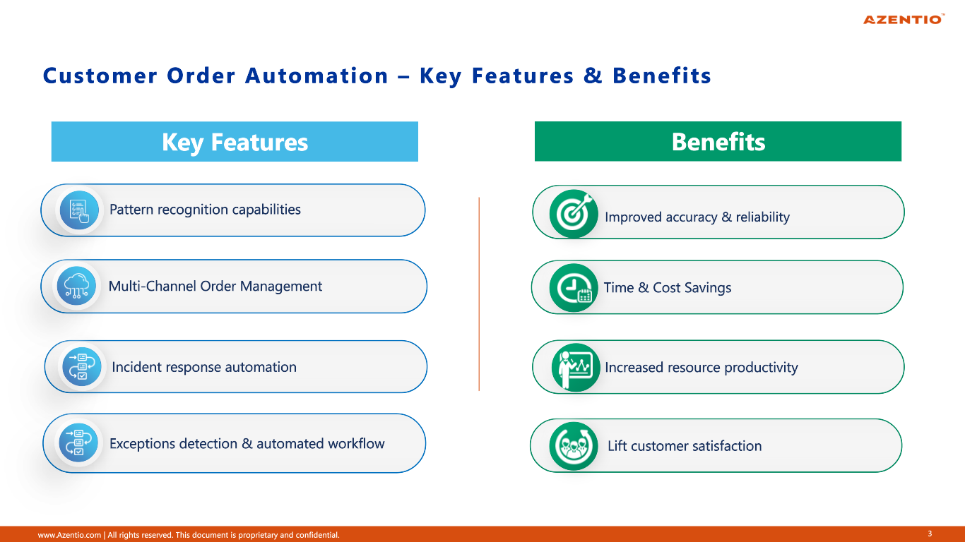

Sales Processing:

FEG processing
Financial Entry Generation (FEG) processing screen is used to make financial entries in the GL.

Stock confirmation
Stock Confirmation is used to update the confirmed stock in Inventory for all the receipt/issue transactions. Unconfirmed Receipts and Unconfirmed Issues of the respective transactions are updated in the confirmed stock at Company Location levels.

Blacklisted customer
The Blacklist Console screen allows the user to mark a customer as a blacklisted customer or to release a customer from the blacklisted list that is already marked as blacklist. The blacklisted customer is not allowed for further transaction. Once the customer is released from the blacklist, he can do further transactions with the organization.

Sales Queries

Customer status
The query screen guides the user in managing customer-related information. Click the buttons on the query screen to view related information.

Order to Cash (O2C) Workbench
Order to Cash Workbench gives you a complete overview of Sales process pack transactions, making it easier to track and manage everything in one place.
Prerequisite – Ensure the Module field is selected as Sales in OSM for the respective process pack to be part of Workbench.
- Navigation – Sales -> My Queries -> Work Bench – Order to Cash.
- Works for all types of Sales processes packs.
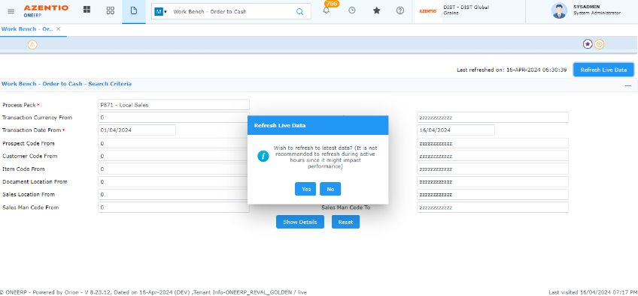
- View every single transaction made.
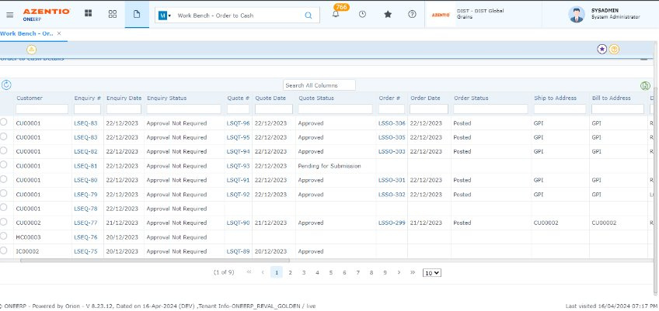
- See how different transactions are connected.
- Check the status of each transaction.
- See the items, quantities, and other details for any selected period and transactions.
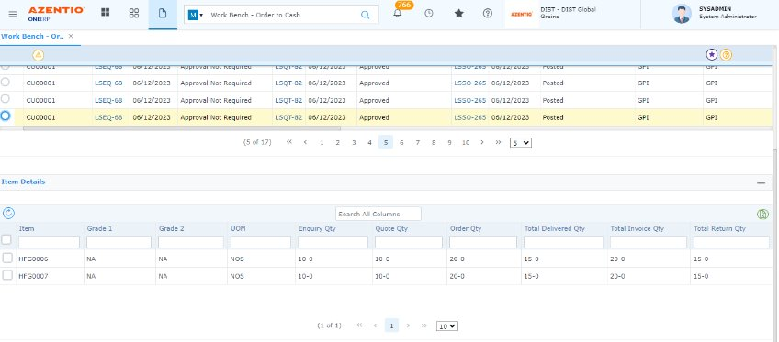
- Using hyperlinks in this screen, the user can move to respective transactions which are available.
- Export these details as needed to an Excel file.
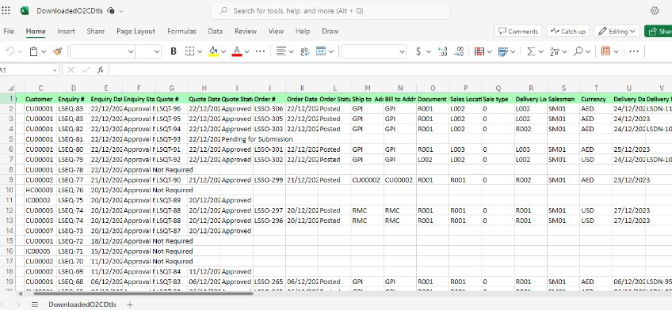

Mobility Solution
Customer status -Functional Features
- Customer status is like a dashboard it will show the Credit limit, available balance, total sales & outstanding for the selected customer.
- As well, pending invoices and pending collection for the selected customer.

View order status query
The screen shows all sales Orders with Document number, document date, Item Code, Grade 1&2, Qty, Customer code and name.

Sales Reports

Sales enquiry
The report displays the Sales Enquiry Summary details.

Sales quotation
The report displays the Sales Quotation Summary details.

Sales order
The report displays the details of Sales order pending for Delivery Note or Sales Invoice. The report permits obtaining data by Document Number, Customer, or Salesman.

Sales invoice
This report displays the Sales Amount by Location and Customer. In addition, it displays the TED details.

Sales return
This report displays all sales return documents according to date range.

Monthly Sales
The report displays monthly sales for a specific year on the basis of Item Codes and Item Analysis codes.

Yearly Sales Analysis
The report displays Yearly sales for a specific year on the basis of Item Codes and Item Analysis codes.

Sales summary with TED by product by customer
This report shows that sales summary with Tax, Exchange and Discount with detail manner based on date, customer, Sales, Item.

FOC quantity sold
The report displays Sales details of Free of Cost (FOC) items for a specific Date range. The Report Generation is based on Individual or Group Location Codes, Salesman Code, Transaction Codes, and Analysis Codes.

Daily sales and collection summary
This report shows the daily sales and collection summary based on Date.

Credit limit utilization
This report lists invoices/sales orders that have exceeded the credit limit during the period. This report adds the SO amount also for the purpose of calculating
Utilized Amount.

Consolidated sales by location type
This report displays the Summary of Sales by Quantity and Value. The summary is based on the sales made during the period by a particular location type.

Profitability analysis-After tax
This report presents profitability analysis after tax, categorized by item, salesman, location, and customer.

Consolidated sales
This report displays the Summary of Sales by Quantity and Value. The summary is based on the sales made during the period by a particular location type.

Sales tax register
The Sales Tax Register Report summarizes and presents a detailed record of sales transactions, including associated sales tax amounts, providing a comprehensive overview for tax compliance and financial analysis.

Sales collection outstanding by customer
This report gives the summary of the all the Invoices generated during the period for which collection is outstanding from a particular customer in a particular location.

Sales by salesman
This report displays the Sales by salesman with salesman, item and Quantity and Value. This is based on the sales made during the period for a particular location type.

Sales register
This report displays the Sales Amount by Location and Customer. In addition, it displays the TED details.

Credit limit exception
This report lists invoices/sales orders that have exceeded the credit limit during the period. If the Sales Order option is selected, the report gives details of the SO by each customer. This amount is not to be considered as Utilized Amount. If Both option is selected, then the application adds the SO amount also for the purpose of calculating Utilized Amount.

Sales target
Based on sales target document level you can view the report with periods budget value and actual value.

Pending sales values
The Pending Sales Values Report summarizes the monetary value of sales transactions that are currently in a pending or incomplete status, providing insights into anticipated revenue upon fulfillment.

PLM Plan vs Actual Report
- Compares projected sales volume Vs Actual Sales Volume for the period
- To provide traceability of product life cycle stages and current position
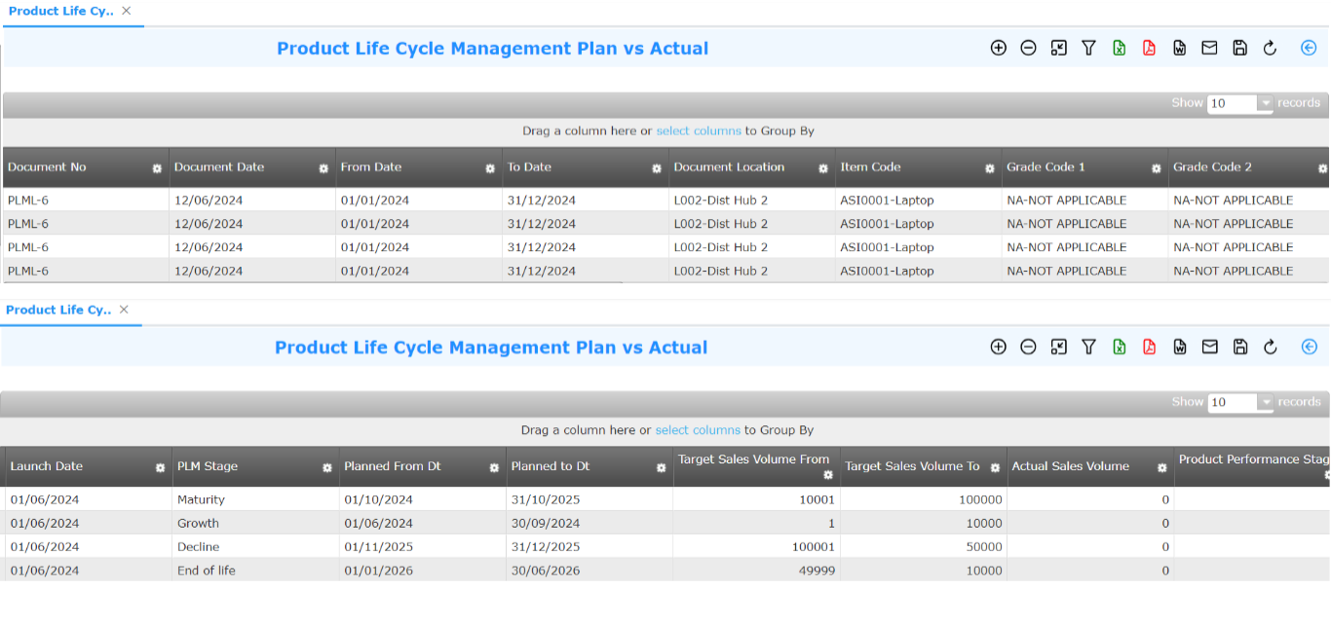

VAT Reporting enhancements
Added essential VAT reports to be compliant for UAE-based businesses. These reports include the
- VAT Input Report, (Navigation – Statutory -> VAT -> VAT Input Report)
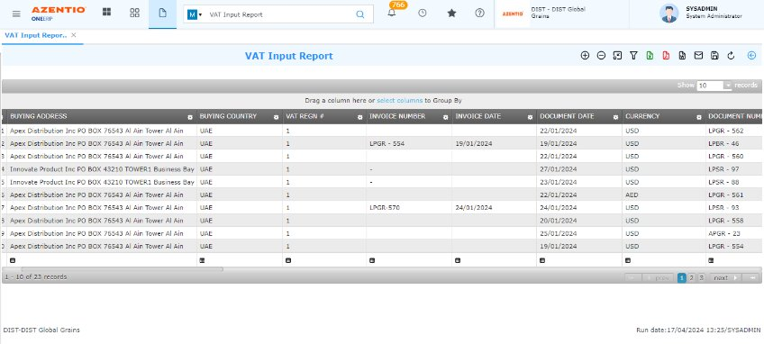
- VAT Output Report, (Navigation – Statutory -> VAT -> VAT Output Report)
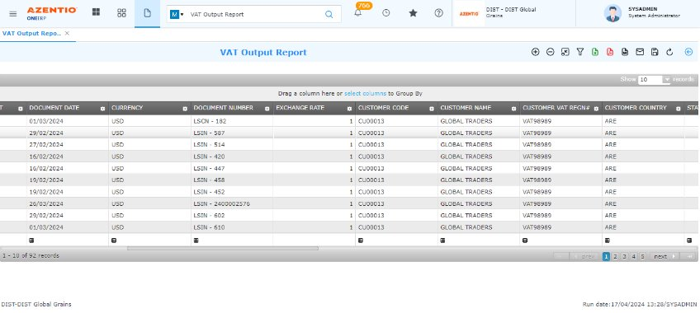
- VAT Return Report (Navigation – Statutory -> VAT -> VAT Return Report).
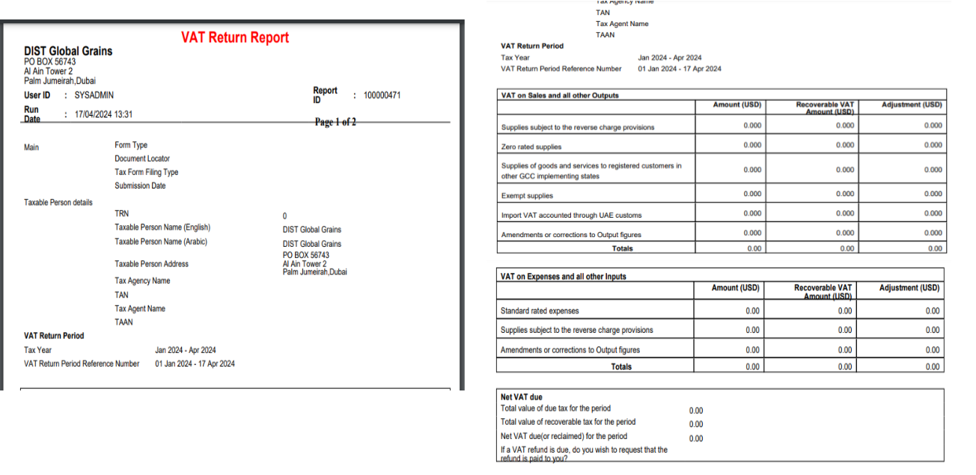
These reports will help streamline VAT compliance and reporting processes.

Sales Document Prints
These are the document prints available for Sales transactions.

- Sales enquiry
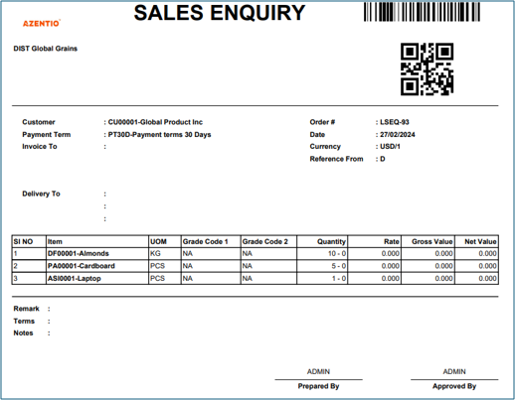

- Sales Quotation
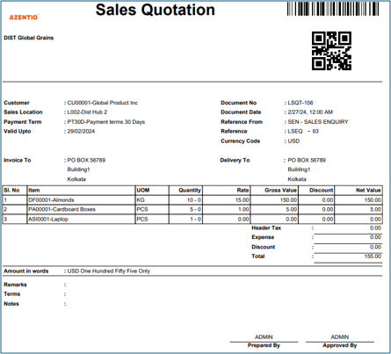

- Sales Order
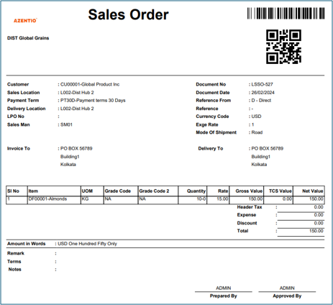

- Delivery Note
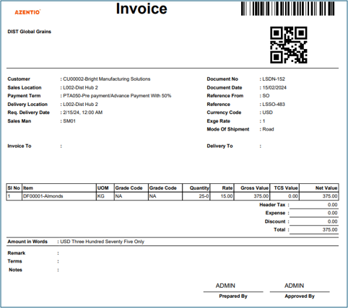
- Delivery Note-Halal

- Invoice to customer
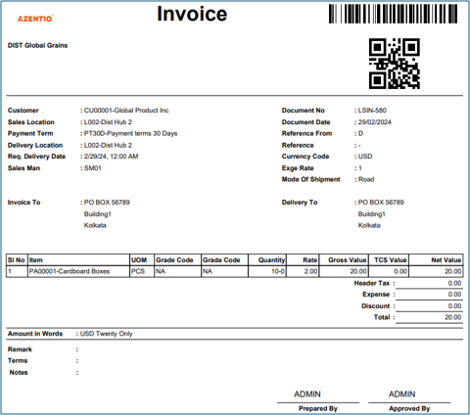
- Invoice to Customer - Halal
- Sales Return
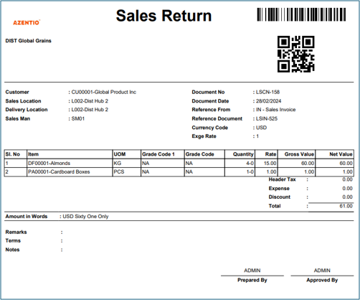

Sales Role Board
Based on the role undertaken by each profile ONEERP Cloud allows to switch between Company and Role. Role based customization of the application enables user to set up a workspace in application which is conducive and productive according to the demands of his role.
In Sales we have two role board
- Sales Manager
- Sales Executive

Sales Dashboard details
Description | Type
360 | 360
Stock Summary List | Portlet
Customer Wise SO Summary | Portlet
Net Sales for the Month | Tile
Profit Percentage for the Month | Tile
Sales Quotation to Sales Order Percentage | Tile
Net Sales per Salesman | Tile
Active Customer Count | Tile
360 | 360
Pending SO | Tile
Sales Return | Tile
Pending Delivery Note | Tile
Shipped But not invoiced Sales Order | Tile
Avg Sale Order Entered per Day | Tile
12 Months SO | Portlet
Top 10 Customer Outstanding Values | Portlet

Features covered in Mobility
- Sales Quote
- Sales Order
- Sales Invoice
- Sales Return
- Price List Update
- Customer status
- Sales Analysis

About Azentio Software
Azentio provides core software to BFSI clients and mid-market ERP systems across the Middle East, Africa, and Asia Pacific. The company is committed to partner with its clients globally to transform their business operations through continuous focus on innovation and best-in-class customer service. Azentio has over 1,000 clients in more than 65 countries.
Headquartered in Singapore, the company has offices in 9 countries with a skilled and talented workforce of over 2,000 employees. Azentio Software Private Limited is owned by funds advised by Apax Partners: www.azentio.com

Head Office
38 Beach Road, #29-11 South Beach Tower, Singapore 189767

